15日全国主要城市线材价格汇总
查看历史数据2017-03-15 14:25 来源：我的钢铁 资讯监督 用手机看行情
分享到： 新浪微博 QQ空间 腾讯微博 微信 打印 更多 0
线材 | 上海 | 杭州 | 南京 | 济南 | 合肥 | 福州 | 南昌 | 广州 | 长沙 | 武汉 | 郑州 | 北京 | 天津 | 石家庄 | 太原 | 沈阳 | 哈尔滨 | 重庆 | 成都 | 贵阳 | 昆明 | 西安 | 兰州 | 乌鲁木齐 | 均价
6.5高线HPB300 | - | 4000 | 4050 | - | 4240 | 3960 | 3880 | 4220 | 3970 | 4030 | 3910 | 4040 | 3720 | - | 3850 | 3820 | 3840 | 4100 | 4080 | 4180 | 4440 | 3920 | 4040 | 3770 | 4003
涨跌 | - | +20 | +40 | - | +10 | 0 | +50 | 0 | +10 | +50 | +40 | 0 | +30 | - | +60 | +20 | +50 | +10 | +20 | 0 | +30 | +30 | +60 | 0 | +25
产地 | - | 中天 | 萍钢 | 莱钢永锋 | 马钢 | 三钢 | 南（昌）钢 | 韶钢 | 萍钢 | 鄂钢 | 信钢 | 河钢承钢 | 国义 | 邯钢 | 首钢长治 | 北台 | 西钢 | 达钢 | 达钢 | 水钢 | 昆钢 | 龙钢 | 酒钢 | 八钢 | -
 | 现货 | 现货 | 现货 | 现货 | 现货 | 现货 | 现货 | 现货 | 现货 | 现货 | 现货 | 现货 | 现货 | 现货 | 现货 | 现货 | 现货 | 现货 | 现货 | 现货 | 现货 | 现货 | 现货 | 现货
8.0高线HPB300 | 3980 | 4000 | 4050 | 4150 | 4240 | 3980 | 3880 | 4190 | 3970 | 4030 | 3910 | 4010 | 3580 | - | 3850 | 3770 | 3790 | 4050 | 4030 | 4180 | 4440 | 3870 | 3990 | 3770 | 3987
涨跌 | +30 | +20 | +40 | -30 | +10 | +50 | +50 | 0 | +10 | +50 | +40 | 0 | +30 | - | +60 | +20 | +50 | +10 | +20 | 0 | +30 | +30 | +10 | 0 | +23
产地 | 中天 | 中天 | 萍钢 | 莱钢永锋 | 马钢 | 三钢 | 南（昌）钢 | 韶钢 | 萍钢 | 鄂钢 | 信钢 | 河钢承钢 | 安丰 | 邯钢 | 首钢长治 | 北台 | 西钢 | 达钢 | 达钢 | 水钢 | 昆钢 | 龙钢 | 酒钢 | 八钢 | -
 | 现货 | 现货 | 现货 | 现货 | 现货 | 现货 | 现货 | 现货 | 现货 | 现货 | 现货 | 现货 | 现货 | 现货 | 现货 | 现货 | 现货 | 现货 | 现货 | 现货 | 现货 | 现货 | 现货 | 现货
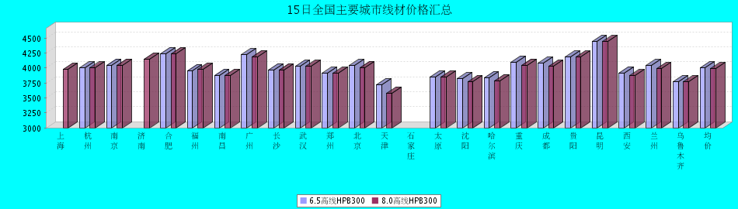
8.0高线HPB300价格走势图
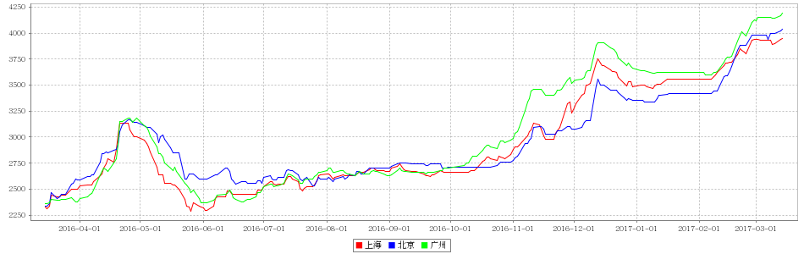
8.0高线HPB235价格走势图
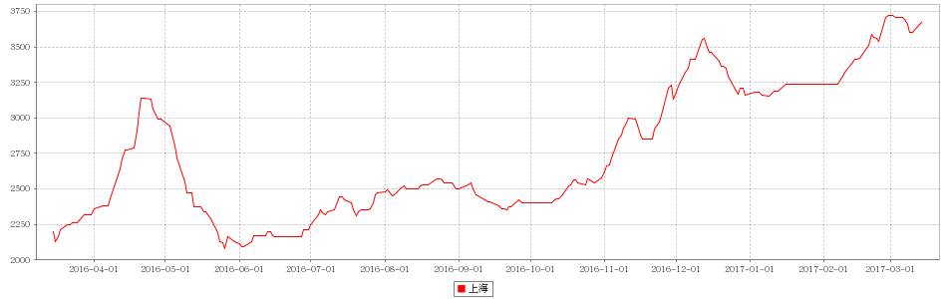

15日全国主要城市HRB400螺纹钢价格汇总
查看历史数据2017-03-15 14:25 来源：我的钢铁 资讯监督 用手机看行情
螺纹钢 | 上海 | 杭州 | 南京 | 济南 | 合肥 | 福州 | 南昌 | 南宁 | 广州 | 长沙 | 武汉 | 郑州 | 北京 | 天津 | 石家庄 | 太原 | 沈阳 | 哈尔滨 | 重庆 | 成都 | 贵阳 | 昆明 | 西安 | 兰州 | 乌鲁木齐 | 均价
HRB400 12MM | 3940 | 3940 | 4060 | 4070 | 4210 | 3900 | 3880 | 4280 | 4460 | 4250 | 3920 | 4140 | 3860 | 3890 | 4010 | 3920 | 3800 | 3770 | 4120 | 4220 | 4310 | 4580 | 3890 | 4110 | 4040 | 4063
涨幅 | +40 | +30 | +40 | +10 | +30 | 0 | +50 | +30 | 0 | +10 | +30 | +40 | +20 | +10 | 0 | +90 | +60 | +30 | +10 | +30 | 0 | +30 | +50 | +10 | 0 | +26
产地 | 申特 | 中天 | 永钢 | 莱钢 | 马钢 | 三钢 | 南(昌)钢 | 柳钢 | 韶钢 | 涟钢 | 新兴铸管 | 安钢 | 河钢承钢 | 河钢承钢 | 邯钢 | 首钢长治 | 新抚钢 | 西钢 | 达钢 | 威钢 | 水钢 | 昆钢 | 龙钢 | 酒钢 | 八钢 | -
计重方式 | 理计 | 理计 | 理计 | 理计 | 理计 | 理计 | 理计 | 理计 | 过磅 | 过磅 | 理计 | 理计 | 理计 | 理计 | 理计 | 理计 | 理计 | 理计 | 过磅 | 过磅 | 过磅 | 理计 | 理计 | 理计 | 理计 | -
30天均价 | 3819 | 3827 | 3957 | 4032 | 4106 | 3896 | 3806 | 4158 | 4258 | 4263 | 3839 | 4070 | 3717 | 3731 | 3941 | 3884 | 3689 | 3656 | 4130 | 4203 | 4172 | 4494 | 3821 | 4100 | 3938 | 3980
 | 现货 | 现货 | 现货 | 现货 | 现货 | 现货 | 现货 | 现货 | 现货 | 现货 | 现货 | 现货 | 现货 | 现货 | 现货 | 现货 | 现货 | 现货 | 现货 | 现货 | 现货 | 现货 | 现货 | 现货 | 现货
HRB400 20MM | 3790 | 3800 | 3900 | 3950 | 4110 | 3780 | 3760 | 4130 | 4260 | 4050 | 3770 | 4000 | 3850 | 3850 | 3940 | 3820 | 3650 | 3660 | 3970 | 4020 | 4160 | 4360 | 3770 | 3910 | 3790 | 3922
涨幅 | +40 | +30 | +40 | +10 | +30 | 0 | +50 | +30 | +30 | +10 | +30 | +40 | +20 | +20 | 0 | +90 | +20 | +30 | +10 | +30 | 0 | +30 | +50 | +10 | 0 | +26
产地 | 中天 | 中天 | 沙钢 | 莱钢 | 马钢 | 三钢 | 南(昌)钢 | 柳钢 | 韶钢 | 涟钢 | 萍钢 | 安钢 | 河钢承钢 | 河钢承钢 | 邯钢 | 首钢长治 | 新抚钢 | 西钢 | 达钢 | 威钢 | 水钢 | 昆钢 | 龙钢 | 酒钢 | 八钢 | -
计重方式 | 理计 | 理计 | 理计 | 理计 | 理计 | 理计 | 理计 | 理计 | 过磅 | 过磅 | 理计 | 理计 | 理计 | 理计 | 理计 | 理计 | 理计 | 理计 | 过磅 | 过磅 | 过磅 | 理计 | 理计 | 理计 | 理计 | -
30天均价 | 3677 | 3688 | 3790 | 3912 | 3986 | 3753 | 3690 | 4014 | 4043 | 4063 | 3684 | 3981 | 3723 | 3720 | 3876 | 3784 | 3568 | 3548 | 3980 | 3996 | 4022 | 4274 | 3701 | 3894 | 3688 | 3842
 | 现货 | 现货 | 现货 | 现货 | 现货 | 现货 | 现货 | 现货 | 现货 | 现货 | 现货 | 现货 | 现货 | 现货 | 现货 | 现货 | 现货 | 现货 | 现货 | 现货 | 现货 | 现货 | 现货 | 现货 | 现货
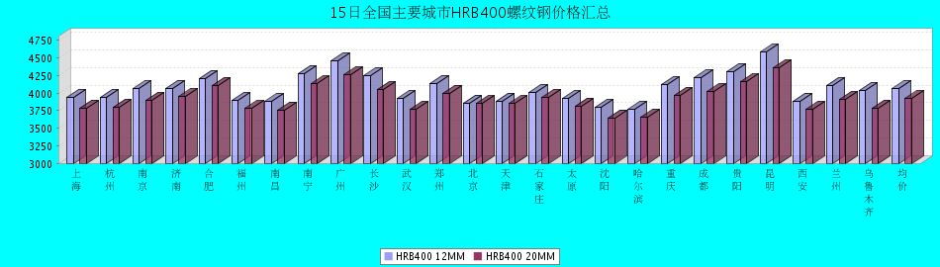
HRB400螺纹钢12MM价格走势图
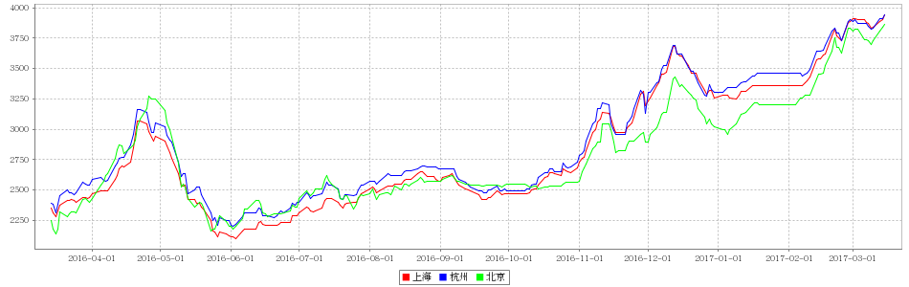
HRB400螺纹钢20MM价格走势图
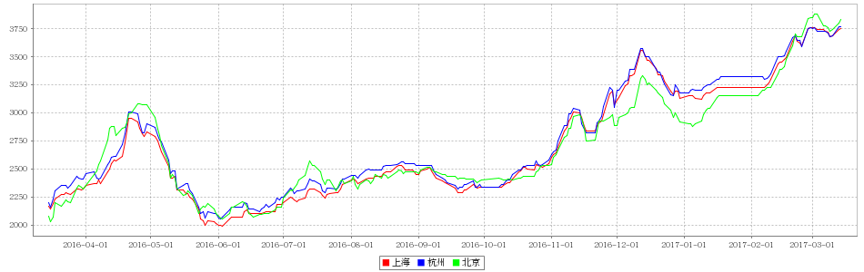

15日全国主要城市盘螺价格汇总
查看历史数据2017-03-15 15:12 来源：我的钢铁 资讯监督 用手机看行情
盘螺 | 上海 | 杭州 | 南京 | 济南 | 合肥 | 福州 | 南昌 | 南宁 | 广州 | 长沙 | 武汉 | 郑州 | 北京 | 天津 | 石家庄 | 太原 | 沈阳 | 哈尔滨 | 重庆 | 成都 | 贵阳 | 昆明 | 西安 | 兰州 | 乌鲁木齐 | 全国均价
HRB400(E) 8mm | 3980 | 4010 | 4150 | 4150 | 4320 | 4080 | 3960 | 4250 | 4400 | 4080 | 4050 | 4060 | 3870 | 3870 | 4090 | 3920 | 3860 | 3940 | 4110 | 4180 | 4310 | 4500 | 3940 | 4060 | 3900 | 4082
涨跌 | +30 | +20 | +40 | 0 | +10 | 0 | +50 | +20 | 0 | +10 | +50 | +50 | 0 | 0 | +20 | +80 | +20 | +50 | +10 | +30 | 0 | +30 | +50 | +10 | 0 | +24
产地 | 中天 | 中天 | 永钢 | 莱钢永锋 | 马钢 | 三钢 | 南（昌）钢 | 柳钢 | 韶钢 | 湘钢 | 鄂钢 | 济源 | 河钢承钢 | 河钢唐钢 | 邯钢 | 首钢长治 | 新抚钢 | 西林 | 水钢 | 威钢 | 水钢 | 昆钢 | 龙钢 | 酒钢 | 八钢 | -
 | 现货 | 现货 | 现货 | 现货 | 现货 | 现货 | 现货 | 现货 | 现货 | 现货 | 现货 | 现货 | 现货 | 现货 | 现货 | 现货 | 现货 | 现货 | 现货 | 现货 | 现货 | 现货 | 现货 | 现货 | 现货
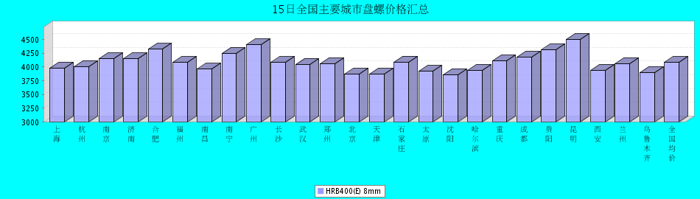

15日全国主要城市中厚板价格汇总 更新中... ...
查看历史数据2017-03-15 15:15 来源：我的钢铁 资讯监督 用手机看行情
分享到： 新浪微博 QQ空间 腾讯微博 微信 打印 更多 0
中板 | 上海 | 杭州 | 南京 | 济南 | 合肥 | 福州 | 南昌 | 广州 | 长沙 | 武汉 | 郑州 | 北京 | 天津 | 石家庄 | 太原 | 沈阳 | 哈尔滨 | 重庆 | 成都 | 昆明 | 西安 | 兰州 | 乌鲁木齐 | 均价
普8mm | 3940 | 3910 | - | 4050 | 4090 | 4100 | 3950 | 4260 | 3980 | 4040 | 4190 | - | 3980 | 3990 | 4040 | 3920 | 4140 | 4400 | 4270 | 4150 | 4030 | 4250 | 4280 | 4093
涨跌 | 0 | +20 | - | +30 | +30 | 0 | +30 | +10 | +20 | 0 | +10 | - | +20 | +10 | +40 | 0 | 0 | +20 | +10 | 0 | +50 | 0 | 0 | +14
产地 | 萍钢 | 萍钢 | 萍钢 | 济钢 | 马钢 | 三钢 | 新余 | 韶钢 | 新余 | 邯钢 | 邯钢 | - | 天钢 | 邯钢 | 太钢 | 鞍钢 | 鞍钢 | 重钢 | 酒钢 | 柳钢 | 酒钢 | 酒钢 | 八钢 | -
 | 现货 | 现货 | 现货 | 现货 | 现货 | 现货 | 现货 | 现货 | 现货 | 现货 | 现货 | 现货 | 现货 | 现货 | 现货 | 现货 | 现货 | 现货 | 现货 | 现货 | 现货 | 现货 | 现货
普20mm | 3730 | 3730 | 3730 | 3780 | 3810 | 3850 | 3780 | 3850 | 3770 | 3670 | 3820 | 3720 | 3680 | 3670 | 3770 | 3660 | 3810 | 3910 | 3960 | 4000 | 3720 | 3800 | 4010 | 3793
涨跌 | 0 | +20 | 0 | +30 | +30 | 0 | +30 | +10 | +20 | 0 | +10 | 0 | +20 | +10 | +40 | 0 | 0 | +20 | +10 | 0 | +50 | 0 | 0 | +13
产地 | 萍钢 | 萍钢 | 萍钢 | 济钢 | 马钢 | 三钢 | 新余 | 韶钢 | 湘钢 | 鄂钢 | 安阳 | 敬业 | 天钢 | 敬业 | 文丰 | 鞍钢 | 鞍钢 | 重钢 | 酒钢 | 柳钢 | 酒钢 | 酒钢 | 八钢 | -
 | 现货 | 现货 | 现货 | 现货 | 现货 | 现货 | 现货 | 现货 | 现货 | 现货 | 现货 | 现货 | 现货 | 现货 | 现货 | 现货 | 现货 | 现货 | 现货 | 现货 | 现货 | 现货 | 现货
低合金20mm | 3860 | 3860 | 3860 | 3910 | 3960 | 4000 | 3880 | 4000 | 3920 | 3820 | 3930 | 3880 | 3830 | 3820 | 3910 | 3860 | 4030 | 4040 | 4110 | 4140 | 3860 | 3910 | 4130 | 3936
涨跌 | 0 | +20 | 0 | +30 | +30 | 0 | +30 | +10 | +20 | 0 | +10 | 0 | +20 | +10 | +40 | 0 | 0 | +20 | +10 | 0 | +50 | 0 | 0 | +13
产地 | 萍钢 | 萍钢 | 萍钢 | 济钢 | 马钢 | 三钢 | 新余 | 韶钢 | 湘钢 | 鄂钢 | 安阳 | 敬业 | 天钢 | 敬业 | 文丰 | 鞍钢 | 鞍钢 | 重钢 | 酒钢 | 韶钢 | 酒钢 | 酒钢 | 八钢 | -
 | 现货 | 现货 | 现货 | 现货 | 现货 | 现货 | 现货 | 现货 | 现货 | 现货 | 现货 | 现货 | 现货 | 现货 | 现货 | 现货 | 现货 | 现货 | 现货 | 现货 | 现货 | 现货 | 现货
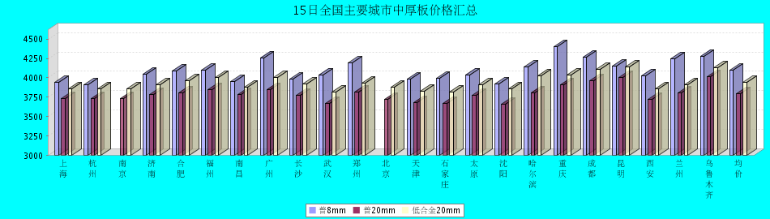
普8mm价格走势图
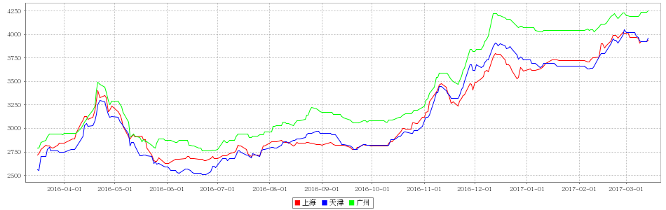
普20mm价格走势图
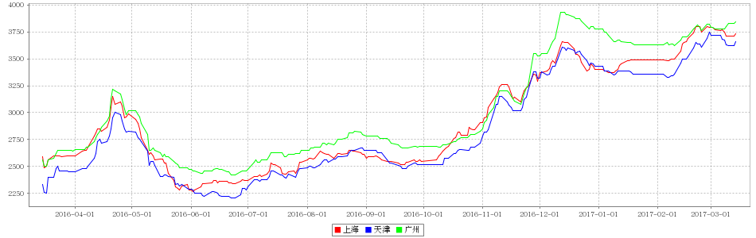
低合金20mm价格走势图
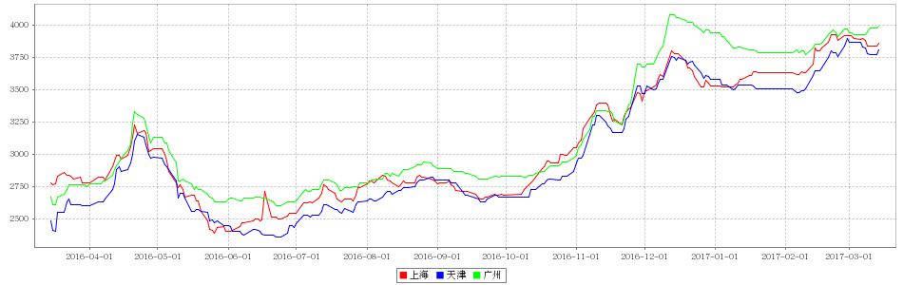

15日全国主要城市焊管价格汇总 更新中... ...
查看历史数据2017-03-15 11:56 来源：我的钢铁 资讯监督 用手机看行情
直缝焊管 | 上海 | 杭州 | 南京 | 济南 | 合肥 | 福州 | 南昌 | 北京 | 天津 | 唐山 | 邯郸 | 包头 | 太原 | 广州 | 南宁 | 长沙 | 武汉 | 郑州 | 沈阳 | 长春 | 哈尔滨 | 重庆 | 成都 | 昆明 | 西安 | 兰州 | 乌鲁木齐 | 平均价
1.5寸*3.25 | 3820 | 3970 | 3950 | 3820 | 3800 | 4160 | 4030 | 3790 | 3660 | 3620 | 3800 | 3680 | 3750 | 4040 | 4150 | 4130 | 3950 | 3810 | 3750 | 3800 | 3680 | 4160 | 4160 | 4220 | 3930 | 4170 | 4350 | 3931
涨幅 | +70 | +20 | +30 | +20 | 0 | 0 | 0 | +20 | -30 | -30 | +30 | +20 | +20 | +50 | 0 | 0 | +40 | +30 | +30 | +30 | +30 | 0 | +20 | 0 | 0 | 0 | 0 | +14
产地 | 衡水华岐 | 衡水华岐 | 衡水华岐 | 友发/京华 | 天津友发 | 福建辉源 | 天津友发 | 京华 | 友发 | 友发 | 正大/友发 | 友发 | 友发 | 佛山振鸿 | 南宁蓝天 | 邯郸友发 | 正大 | 邯郸正大 | 雷明 | 吉林华歧 | 吉林华岐 | 成都华岐 | 成都华岐 | 通海方圆 | 友发 | 友发 | 八钢 | -
 | 现货 | 现货 | 现货 | 现货 | 现货 | 现货 | 现货 | 现货 | 现货 | 现货 | 现货 | 现货 | 现货 | 现货 | 现货 | 现货 | 现货 | 现货 | 现货 | 现货 | 现货 | 现货 | 现货 | 现货 | 现货 | 现货 | 现货
4寸*3.75 | 3870 | 3920 | 3900 | 3810 | 3770 | 4160 | 3960 | 3720 | 3650 | 3600 | 3750 | 3620 | 3740 | 4090 | 4250 | 4100 | 3930 | 3750 | 3750 | 3800 | 3680 | 4150 | 4150 | 4200 | 3850 | 4070 | 4250 | 3907
涨幅 | +70 | +20 | +30 | +20 | 0 | 0 | 0 | +20 | -30 | -30 | +30 | +20 | +20 | +50 | 0 | 0 | +40 | +30 | +30 | +30 | +30 | 0 | +20 | 0 | 0 | 0 | 0 | +15
产地 | 天津君诚 | 衡水华岐 | 衡水华岐 | 友发/京华 | 天津友发 | 福建辉源 | 天津友发 | 增洲 | 友发 | 增洲 | 正大/友发 | 友发 | 友发 | 佛山振鸿 | 佛山振鸿 | 邯郸友发 | 正大 | 邯郸正大 | 雷明 | 吉林华歧 | 吉林华岐 | 成都华岐 | 成都华岐 | 通海方圆 | 友发 | 友发 | 八钢 | -
 | 现货 | 现货 | 现货 | 现货 | 现货 | 现货 | 现货 | 现货 | 现货 | 现货 | 现货 | 现货 | 现货 | 现货 | 现货 | 现货 | 现货 | 现货 | 现货 | 现货 | 现货 | 现货 | 现货 | 现货 | 现货 | 现货 | 现货
备注 | 过磅 | 过磅 | 过磅 | 过磅 | 过磅 | 过磅 | 过磅 | 过磅 | 过磅 | 过磅 | 过磅 | 过磅 | 过磅 | 过磅 | 过磅 | 过磅 | 过磅 | 过磅 | 过磅 | 过磅 | 过磅 | 过磅 | 过磅 | 过磅 | 过磅 | 过磅 | 过磅 | -
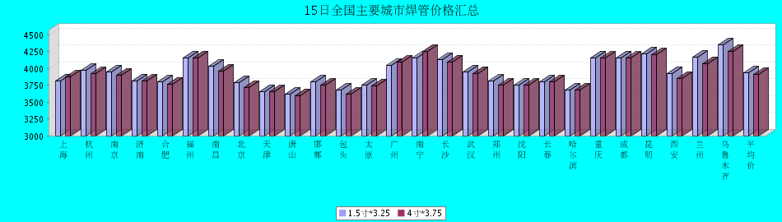

15日全国主要城市H型钢价格汇总 更新中... ...
查看历史数据2017-03-15 14:43 来源：我的钢铁 资讯监督 用手机看行情
分享到： 新浪微博 QQ空间 腾讯微博 微信 打印 更多 0
H型钢 | 上海 | 北京 | 天津 | 杭州 | 无锡 | 唐山 | 济南 | 太原 | 福州 | 成都 | 郑州 | 西安 | 鞍山 | 广州 | 均价
200*100 | 3550 | 3420 | 3440 | 3610 | 3490 | 3450 | 3470 | 3540 | 3750 | 3880 | - | 3980 | 3600 | 3630 | 3601
涨跌 | +30 | 0 | 0 | 0 | 0 | 0 | +40 | 0 | +50 | +10 | - | 0 | 0 | 0 | +10
产地 | 马钢 | 莱\日 | 莱\日 | 马钢 | 莱钢 | 莱\日 | 津西 | 莱钢 | 日照 | 莱钢 | - | 莱钢 | 津西 | 津西 | -
 | 现货 | 现货 | 现货 | 现货 | 现货 | 现货 | 现货 | 现货 | 现货 | 现货 | 现货 | 现货 | 现货 | 现货
300*300 | 3610 | 3520 | 3490 | 3690 | 3590 | 3520 | 3600 | 3690 | 3950 | 3890 | 3610 | 3960 | 3700 | 3830 | 3689
涨跌 | +30 | 0 | 0 | 0 | 0 | 0 | +20 | 0 | +50 | +10 | 0 | 0 | 0 | 0 | +8
产地 | 马钢 | 马\莱 | 马\莱 | 马钢 | 马钢 | 津西 | 津西 | 莱钢 | 日照 | 马钢 | 莱钢 | 莱钢 | 津西 | 马钢 | -
 | 现货 | 现货 | 现货 | 现货 | 现货 | 现货 | 现货 | 现货 | 现货 | 现货 | 现货 | 现货 | 现货 | 现货
400*200 | 3650 | 3540 | 3490 | 3610 | 3600 | 3550 | 3580 | 3690 | 3800 | 3940 | 3600 | 3820 | 3660 | 3740 | 3662
涨跌 | +30 | 0 | 0 | 0 | 0 | 0 | +30 | 0 | +50 | +10 | 0 | 0 | 0 | 0 | +8
产地 | 马钢 | 莱\津 | 莱\津 | 莱钢 | 莱钢 | 津西 | 津西 | 长治 | 日照 | 莱钢 | 莱钢 | 首钢长治 | 津西 | 马钢 | -
 | 现货 | 现货 | 现货 | 现货 | 现货 | 现货 | 现货 | 现货 | 现货 | 现货 | 现货 | 现货 | 现货 | 现货
588*300 | 3630 | 3540 | 3510 | 3780 | 3590 | 3540 | 3580 | 3660 | 3950 | 3880 | 3600 | 4090 | 3700 | 3810 | 3704
涨跌 | +30 | 0 | 0 | 0 | 0 | 0 | +10 | 0 | +50 | +10 | 0 | 0 | 0 | 0 | +7
产地 | 马钢 | 莱\津 | 莱\津 | 马钢 | 莱钢 | 津西 | 津西 | 莱钢 | 日照 | 马钢 | 莱钢 | 莱钢 | 津西 | 津西 | -
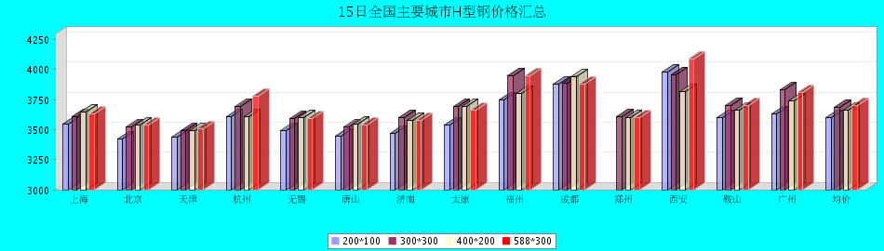

15日全国主要城市工角槽钢价格汇总 更新中... ...
查看历史数据2017-03-15 15:07 来源：我的钢铁 资讯监督 用手机看行情
型材 | 上海 | 杭州 | 南京 | 济南 | 合肥 | 福州 | 南昌 | 广州 | 长沙 | 武汉 | 郑州 | 北京 | 天津 | 石家庄 | 太原 | 沈阳 | 哈尔滨 | 重庆 | 成都 | 昆明 | 西安 | 兰州 | 乌鲁木齐 | 均价
50*5角钢 | 3830 | 3900 | 3900 | 3700 | 3900 | 4050 | 3860 | 3910 | 4200 | 3920 | 3970 | 3340 | 3340 | 3410 | 3780 | 3820 | 3930 | 4020 | 4100 | 4480 | 3780 | 3830 | 3910 | 3864
涨跌 | 0 | 0 | 0 | 0 | 0 | +50 | 0 | 0 | +30 | 0 | 0 | 0 | +10 | +10 | +10 | 0 | 0 | +20 | 0 | 0 | 0 | -150 | 0 | -1
主导钢厂 | 马钢 | 马钢 | 马钢 | 安钢 | 马钢 | 唐山正丰 | 南钢 | 冀丰 | 安钢 | 安钢 | 安钢 | 首钢 | 兆博 | 唐山 | 唐山正丰 | 唐山正丰 | 唐山正丰 | 安阳 | 安阳 | 安钢 | 安钢 | 安钢 | 八钢 | -
 | 现货 | 现货 | 现货 | 现货 | 现货 | 现货 | 现货 | 现货 | 现货 | 现货 | 现货 | 现货 | 现货 | 现货 | 现货 | 现货 | 现货 | 现货 | 现货 | 现货 | 现货 | 现货 | 现货
16＃槽钢 | 3790 | 3840 | 3860 | 3720 | 3830 | 4050 | 3830 | 3910 | 4220 | 3930 | 4060 | 3420 | 3470 | 3500 | 3820 | 3580 | 3730 | 3850 | 3800 | 4400 | 3900 | 4050 | 3920 | 3847
涨跌 | 0 | 0 | 0 | 0 | 0 | +50 | 0 | 0 | +20 | 0 | 0 | 0 | -50 | +50 | 0 | 0 | 0 | +10 | 0 | +50 | 0 | -150 | 0 | -1
主导钢厂 | 马钢 | 马钢 | 马钢 | 济钢 | 马钢 | 唐山鑫诚 | 马钢 | 柳钢 | 东山冶金 | 马钢 | 济钢 | 中德 | 江天 | 唐山 | 唐山瑞隆 | 鞍山宝得 | 鞍山宝得 | 东山 | 东山 | 河北东山 | 河北东山 | 鞍山宝得 | 八钢 | -
 | 现货 | 现货 | 现货 | 现货 | 现货 | 现货 | 现货 | 现货 | 现货 | 现货 | 现货 | 现货 | 现货 | 现货 | 现货 | 现货 | 现货 | 现货 | 现货 | 现货 | 现货 | 现货 | 现货
25＃工字钢 | 3850 | 4010 | 3920 | 3800 | 3930 | 4050 | 4020 | 4270 | 4080 | 4090 | 3780 | 3400 | 3400 | 3450 | 3790 | 3520 | 3660 | 3980 | 3950 | 4280 | 4210 | 4080 | 4270 | 3904
涨跌 | 0 | 0 | 0 | 0 | 0 | +50 | 0 | 0 | 0 | 0 | 0 | 0 | 0 | 0 | 0 | 0 | 0 | +10 | +20 | +30 | 0 | -150 | 0 | -2
主导钢厂 | 莱钢 | 莱钢 | 莱钢 | 莱钢 | 武钢 | 日照 | 莱钢 | 日照 | 莱钢 | 包钢 | 莱钢 | 津西 | 唐山 | 唐山 | 唐山弘泰 | 东四 | 宝得 | 日照 | 日照 | 日照 | 日照 | 莱钢 | 海城 | -
 | 现货 | 现货 | 现货 | 现货 | 现货 | 现货 | 现货 | 现货 | 现货 | 现货 | 现货 | 现货 | 现货 | 现货 | 现货 | 现货 | 现货 | 现货 | 现货 | 现货 | 现货 | 现货 | 现货
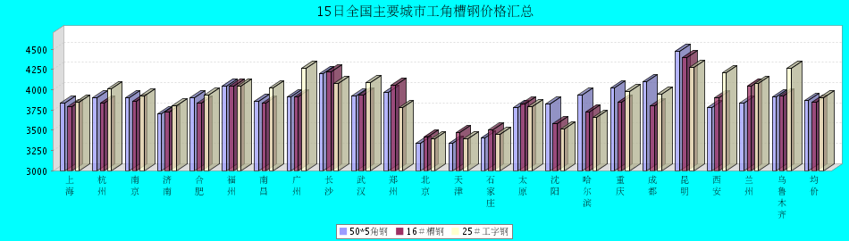

15日全国主要城市镀锌管价格汇总
镀锌焊管 | 上海 | 杭州 | 南京 | 济南 | 合肥 | 福州 | 南昌 | 北京 | 天津 | 唐山 | 邯郸 | 包头 | 太原 | 广州 | 南宁 | 长沙 | 武汉 | 郑州 | 沈阳 | 长春 | 哈尔滨 | 重庆 | 成都 | 昆明 | 西安 | 兰州 | 乌鲁木齐 | 平均价
1.5寸*3.25 | 4660 | 4690 | 4610 | 4730 | 4610 | 4660 | 4780 | 4690 | 4550 | 4570 | 4730 | 4440 | 4570 | 5290 | 4860 | 4930 | 4750 | 4570 | 4580 | 4430 | 4370 | 4850 | 4850 | 4880 | 4680 | 4700 | 4800 | 4697
涨幅 | 0 | +40 | +30 | +20 | +30 | 0 | 0 | 0 | +20 | 0 | +30 | +20 | +20 | +20 | +20 | 0 | 0 | +30 | +30 | +30 | +30 | +20 | 0 | +20 | 0 | 0 | 0 | +15
产地 | 天津君诚 | 衡水华岐 | 衡水华岐 | 友发 | 天津友发 | 君诚 | 邯郸友发 | 利达 | 友发 | 正金元 | 邯郸友发 | 友发 | 友发 | 友发 | 天津君诚 | 邯郸友发 | 邯郸友发 | 邯郸正大 | 正金元 | 吉林华岐 | 吉林华岐 | 成都华岐 | 华歧 | 邯郸友发 | 利达 | 君诚 | 友发 | -
4寸*3.75 | 4430 | 4380 | 4380 | 4440 | 4320 | 4370 | 4510 | 4440 | 4240 | 4260 | 4440 | 4150 | 4280 | 4990 | 4620 | 4630 | 4460 | 4260 | 4240 | 4180 | 4120 | 4530 | 4560 | 4670 | 4480 | 4450 | 4750 | 4429
涨幅 | +30 | +30 | +30 | +20 | +30 | 0 | 0 | 0 | +20 | 0 | +30 | +20 | +20 | +20 | +20 | 0 | 0 | +30 | +30 | +30 | +30 | +20 | 0 | +20 | 0 | 0 | 0 | +16
产地 | 天津友发 | 天津友发 | 天津友发 | 友发 | 天津友发 | 君诚 | 邯郸友发 | 利达 | 友发 | 正金元 | 邯郸友发 | 友发 | 友发 | 友发 | 天津君诚 | 衡水华岐 | 邯郸友发 | 邯郸正大 | 正金元 | 正金元 | 吉林华岐 | 成都华岐 | 华歧 | 邯郸友发 | 利达 | 君诚 | 友发 | -
备注 | 过磅 | 过磅 | 过磅 | 过磅 | 过磅 | 过磅 | 过磅 | 过磅 | 过磅 | 过磅 | 过磅 | 过磅 | 过磅 | 过磅 | 过磅 | 过磅 | 过磅 | 过磅 | 过磅 | 过磅 | 过磅 | 过磅 | 过磅 | 过磅 | 理计 | 过磅 | 过磅 | -
