20日全国主要城市线材价格汇总
查看历史数据2017-03-20 11:17 来源：我的钢铁 资讯监督 用手机看行情
分享到：新浪微博QQ空间腾讯微博微信打印更多0
线材 | 上海 | 杭州 | 南京 | 济南 | 合肥 | 福州 | 南昌 | 广州 | 长沙 | 武汉 | 郑州 | 北京 | 天津 | 石家庄 | 太原 | 沈阳 | 哈尔滨 | 重庆 | 成都 | 贵阳 | 昆明 | 西安 | 兰州 | 乌鲁木齐 | 均价
6.5高线HPB300 | - | 3980 | 4040 | - | 4220 | 3960 | 3850 | - | 3960 | 4040 | 3920 | 4040 | 3730 | - | 3880 | 3880 | 3870 | 4100 | 4070 | 4200 | 4470 | 3920 | 3980 | 3770 | 3994
涨跌 | - | 0 | 0 | - | 0 | +50 | 0 | - | -40 | 0 | +10 | 0 | 0 | - | 0 | 0 | 0 | 0 | 0 | 0 | 0 | 0 | -60 | 0 | -14
产地 | - | 中天 | 萍钢 | 莱钢永锋 | 马钢 | 三钢 | 南（昌）钢 | 韶钢 | 萍钢 | 鄂钢 | 信钢 | 河钢承钢 | 国义 | 邯钢 | 首钢长治 | 北台 | 西钢 | 达钢 | 达钢 | 水钢 | 昆钢 | 龙钢 | 酒钢 | 八钢 | -
 | 现货 | 现货 | 现货 | 现货 | 现货 | 现货 | 现货 | 现货 | 现货 | 现货 | 现货 | 现货 | 现货 | 现货 | 现货 | 现货 | 现货 | 现货 | 现货 | 现货 | 现货 | 现货 | 现货 | 现货
8.0高线HPB300 | 3950 | 3980 | 4040 | 4060 | 4220 | 3980 | 3850 | - | 3960 | 4040 | 3920 | 4000 | 3550 | - | 3880 | 3830 | 3820 | 4050 | 4020 | 4200 | 4470 | 3870 | 3980 | 3770 | 3975
涨跌 | 0 | 0 | 0 | -90 | 0 | +100 | 0 | - | -40 | 0 | +10 | 0 | 0 | - | 0 | 0 | 0 | 0 | 0 | 0 | 0 | 0 | -10 | 0 | -12
产地 | 中天 | 中天 | 萍钢 | 莱钢永锋 | 马钢 | 三钢 | 南（昌）钢 | 韶钢 | 萍钢 | 鄂钢 | 信钢 | 河钢承钢 | 安丰 | 邯钢 | 首钢长治 | 北台 | 西钢 | 达钢 | 达钢 | 水钢 | 昆钢 | 龙钢 | 酒钢 | 八钢 | -
 | 现货 | 现货 | 现货 | 现货 | 现货 | 现货 | 现货 | 现货 | 现货 | 现货 | 现货 | 现货 | 现货 | 现货 | 现货 | 现货 | 现货 | 现货 | 现货 | 现货 | 现货 | 现货 | 现货 | 现货
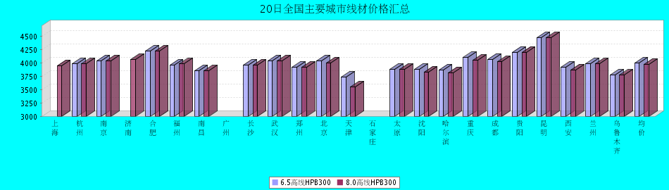
8.0高线HPB300价格走势图
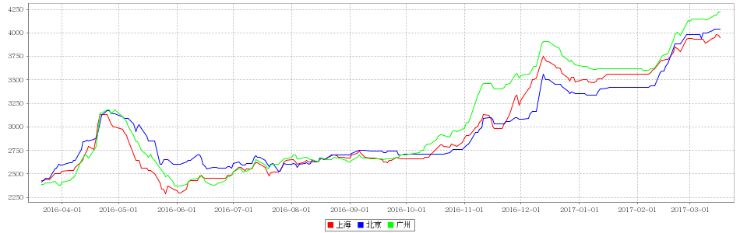
8.0高线HPB235价格走势图
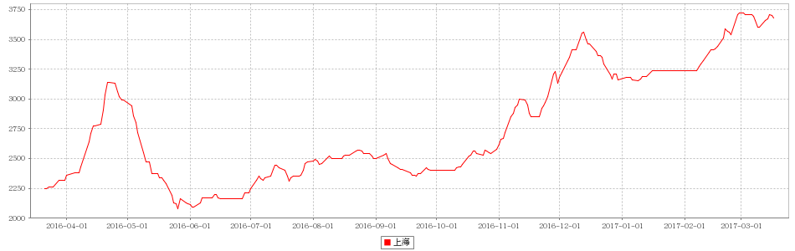

20日全国主要城市HRB400螺纹钢价格汇总
查看历史数据2017-03-20 11:29 来源：我的钢铁 资讯监督 用手机看行情
分享到：新浪微博QQ空间腾讯微博微信打印更多0
螺纹钢 | 上海 | 杭州 | 南京 | 济南 | 合肥 | 福州 | 南昌 | 南宁 | 广州 | 长沙 | 武汉 | 郑州 | 北京 | 天津 | 石家庄 | 太原 | 沈阳 | 哈尔滨 | 重庆 | 成都 | 贵阳 | 昆明 | 西安 | 兰州 | 乌鲁木齐 | 均价
HRB400 12MM | 3900 | 3910 | 4060 | 4070 | 4220 | 3900 | 3850 | 4210 | - | 4230 | 3950 | 4130 | 3790 | 3810 | 3960 | 3950 | 3860 | 3830 | 4120 | 4190 | 4330 | 4580 | 3910 | 4100 | 4040 | 4038
涨幅 | 0 | 0 | 0 | -30 | 0 | +50 | 0 | -20 | - | -40 | 0 | +10 | -20 | -20 | -30 | 0 | 0 | 0 | 0 | 0 | 0 | 0 | 0 | -10 | 0 | -21
产地 | 申特 | 中天 | 永钢 | 莱钢 | 马钢 | 三钢 | 南(昌)钢 | 柳钢 | 韶钢 | 涟钢 | 新兴铸管 | 安钢 | 河钢承钢 | 河钢承钢 | 邯钢 | 首钢长治 | 新抚钢 | 西钢 | 达钢 | 威钢 | 水钢 | 昆钢 | 龙钢 | 酒钢 | 八钢 | -
计重方式 | 理计 | 理计 | 理计 | 理计 | 理计 | 理计 | 理计 | 理计 | 过磅 | 过磅 | 理计 | 理计 | 理计 | 理计 | 理计 | 理计 | 理计 | 理计 | 过磅 | 过磅 | 过磅 | 理计 | 理计 | 理计 | 理计 | -
30天均价 | 3862 | 3862 | 4003 | 4042 | 4147 | 3908 | 3838 | 4208 | - | 4284 | 3885 | 4105 | 3764 | 3781 | 3982 | 3906 | 3743 | 3714 | 4146 | 4222 | 4224 | 4533 | 3852 | 4121 | 3980 | 4005
 | 现货 | 现货 | 现货 | 现货 | 现货 | 现货 | 现货 | 现货 | 现货 | 现货 | 现货 | 现货 | 现货 | 现货 | 现货 | 现货 | 现货 | 现货 | 现货 | 现货 | 现货 | 现货 | 现货 | 现货 | 现货
HRB400 20MM | 3750 | 3770 | 3900 | 3950 | 4100 | 3780 | 3730 | 4060 | - | 4030 | 3800 | 3990 | 3790 | 3770 | 3890 | 3850 | 3710 | 3720 | 3970 | 4010 | 4180 | 4390 | 3790 | 3900 | 3790 | 3901
涨幅 | 0 | 0 | 0 | -30 | 0 | +50 | 0 | -20 | - | -40 | 0 | +10 | -20 | -30 | -20 | 0 | 0 | 0 | 0 | 0 | 0 | 0 | 0 | -10 | 0 | -19
产地 | 中天 | 中天 | 沙钢 | 莱钢 | 马钢 | 三钢 | 南(昌)钢 | 柳钢 | 韶钢 | 涟钢 | 萍钢 | 安钢 | 河钢承钢 | 河钢承钢 | 邯钢 | 首钢长治 | 新抚钢 | 西钢 | 达钢 | 威钢 | 水钢 | 昆钢 | 龙钢 | 酒钢 | 八钢 | -
计重方式 | 理计 | 理计 | 理计 | 理计 | 理计 | 理计 | 理计 | 理计 | 过磅 | 过磅 | 理计 | 理计 | 理计 | 理计 | 理计 | 理计 | 理计 | 理计 | 过磅 | 过磅 | 过磅 | 理计 | 理计 | 理计 | 理计 | -
30天均价 | 3718 | 3724 | 3838 | 3922 | 4028 | 3770 | 3718 | 4060 | - | 4084 | 3732 | 4006 | 3778 | 3774 | 3921 | 3806 | 3616 | 3605 | 3996 | 4012 | 4074 | 4316 | 3732 | 3920 | 3730 | 3870
 | 现货 | 现货 | 现货 | 现货 | 现货 | 现货 | 现货 | 现货 | 现货 | 现货 | 现货 | 现货 | 现货 | 现货 | 现货 | 现货 | 现货 | 现货 | 现货 | 现货 | 现货 | 现货 | 现货 | 现货 | 现货
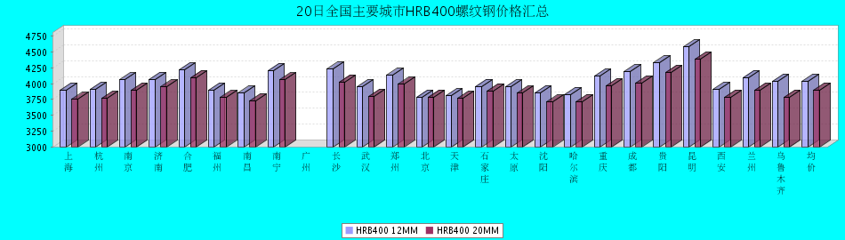
HRB400螺纹钢12MM价格走势图
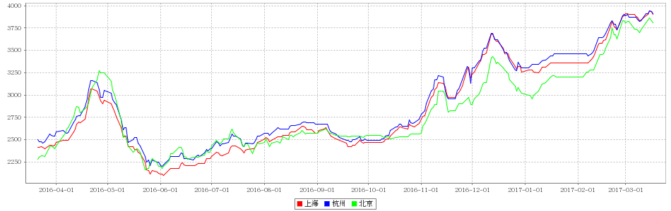
HRB400螺纹钢20MM价格走势图
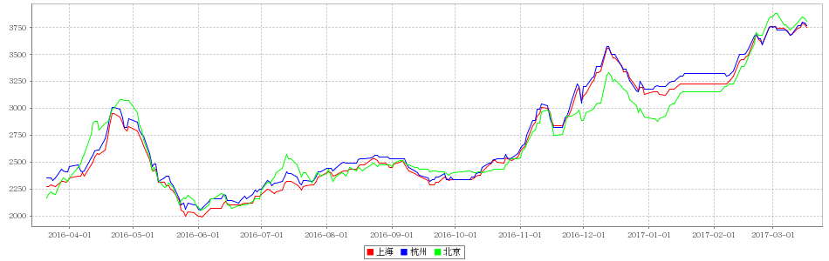

20日全国主要城市盘螺价格汇总
查看历史数据2017-03-20 11:29 来源：我的钢铁 资讯监督 用手机看行情
分享到：新浪微博QQ空间腾讯微博微信打印更多1
盘螺 | 上海 | 杭州 | 南京 | 济南 | 合肥 | 福州 | 南昌 | 南宁 | 广州 | 长沙 | 武汉 | 郑州 | 北京 | 天津 | 石家庄 | 太原 | 沈阳 | 哈尔滨 | 重庆 | 成都 | 贵阳 | 昆明 | 西安 | 兰州 | 乌鲁木齐 | 全国均价
HRB400(E) 8mm | 3960 | 3990 | 4110 | 4060 | 4290 | 4030 | 3930 | 4220 | - | 4060 | 4060 | 4060 | 3840 | 3850 | 4090 | 3950 | 3940 | 3970 | 4110 | 4120 | 4320 | 4580 | 3950 | 4050 | 3900 | 4060
涨跌 | 0 | 0 | 0 | -120 | -20 | +50 | 0 | 0 | - | -40 | 0 | 0 | -10 | 0 | 0 | 0 | 0 | 0 | 0 | 0 | 0 | 0 | 0 | -10 | 0 | -20
产地 | 中天 | 中天 | 永钢 | 莱钢永锋 | 马钢 | 三钢 | 南（昌）钢 | 柳钢 | 韶钢 | 湘钢 | 鄂钢 | 济源 | 河钢承钢 | 河钢唐钢 | 邯钢 | 首钢长治 | 新抚钢 | 西林 | 水钢 | 威钢 | 水钢 | 昆钢 | 龙钢 | 酒钢 | 八钢 | -
 | 现货 | 现货 | 现货 | 现货 | 现货 | 现货 | 现货 | 现货 | 现货 | 现货 | 现货 | 现货 | 现货 | 现货 | 现货 | 现货 | 现货 | 现货 | 现货 | 现货 | 现货 | 现货 | 现货 | 现货 | 现货
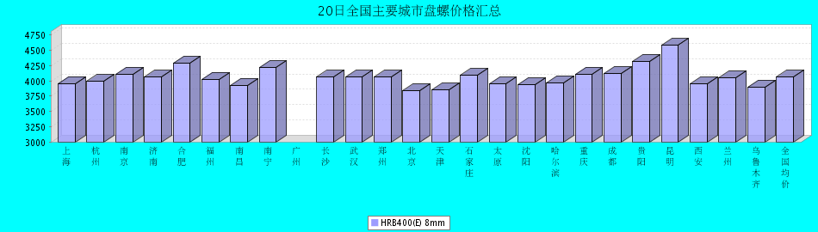

20日全国主要城市中厚板价格汇总
查看历史数据2017-03-20 11:17 来源：我的钢铁 资讯监督 用手机看行情
分享到：新浪微博QQ空间腾讯微博微信打印更多0
中板 | 上海 | 杭州 | 南京 | 济南 | 合肥 | 福州 | 南昌 | 广州 | 长沙 | 武汉 | 郑州 | 北京 | 天津 | 石家庄 | 太原 | 沈阳 | 哈尔滨 | 重庆 | 成都 | 昆明 | 西安 | 兰州 | 乌鲁木齐 | 均价
普8mm | 3950 | 3920 | - | 4070 | 4090 | 4100 | 3930 | 4260 | 3980 | 4050 | 4150 | - | 3980 | 3960 | 4020 | 3910 | 4110 | 4390 | 4280 | 4100 | 4080 | 4250 | - | 4079
涨跌 | +10 | 0 | - | 0 | 0 | 0 | 0 | 0 | -20 | +10 | -20 | - | 0 | -20 | 0 | -30 | -30 | 0 | 0 | -50 | 0 | 0 | - | -17
产地 | 萍钢 | 萍钢 | 萍钢 | 济钢 | 马钢 | 三钢 | 新余 | 韶钢 | 新余 | 邯钢 | 邯钢 | - | 天钢 | 邯钢 | 太钢 | 鞍钢 | 鞍钢 | 重钢 | 酒钢 | 柳钢 | 酒钢 | 酒钢 | 八钢 | -
 | 现货 | 现货 | 现货 | 现货 | 现货 | 现货 | 现货 | 现货 | 现货 | 现货 | 现货 | 现货 | 现货 | 现货 | 现货 | 现货 | 现货 | 现货 | 现货 | 现货 | 现货 | 现货 | 现货
普20mm | 3740 | 3740 | 3730 | 3800 | 3810 | 3850 | 3760 | 3850 | 3770 | 3680 | 3780 | 3690 | 3680 | 3640 | 3750 | 3650 | 3780 | 3900 | 3970 | 4000 | 3770 | 3800 | - | 3779
涨跌 | +10 | 0 | 0 | 0 | 0 | 0 | 0 | 0 | -20 | +10 | -20 | -30 | 0 | -20 | 0 | -30 | -30 | 0 | 0 | 0 | 0 | 0 | - | -16
产地 | 萍钢 | 萍钢 | 萍钢 | 济钢 | 马钢 | 三钢 | 新余 | 韶钢 | 湘钢 | 鄂钢 | 安阳 | 敬业 | 天钢 | 敬业 | 文丰 | 鞍钢 | 鞍钢 | 重钢 | 酒钢 | 柳钢 | 酒钢 | 酒钢 | 八钢 | -
 | 现货 | 现货 | 现货 | 现货 | 现货 | 现货 | 现货 | 现货 | 现货 | 现货 | 现货 | 现货 | 现货 | 现货 | 现货 | 现货 | 现货 | 现货 | 现货 | 现货 | 现货 | 现货 | 现货
低合金20mm | 3870 | 3870 | 3840 | 3930 | 3960 | 4000 | 3860 | 4000 | 3920 | 3830 | 3890 | 3850 | 3830 | 3760 | 3890 | 3850 | 4000 | 4030 | 4120 | 4140 | 3910 | 3910 | - | 3921
涨跌 | +10 | 0 | 0 | 0 | 0 | 0 | 0 | 0 | -20 | +10 | -20 | -30 | 0 | -50 | 0 | -30 | -30 | 0 | 0 | 0 | 0 | 0 | - | -16
产地 | 萍钢 | 萍钢 | 萍钢 | 济钢 | 马钢 | 三钢 | 新余 | 韶钢 | 湘钢 | 鄂钢 | 安阳 | 敬业 | 天钢 | 敬业 | 文丰 | 鞍钢 | 鞍钢 | 重钢 | 酒钢 | 韶钢 | 酒钢 | 酒钢 | 八钢 | -
 | 现货 | 现货 | 现货 | 现货 | 现货 | 现货 | 现货 | 现货 | 现货 | 现货 | 现货 | 现货 | 现货 | 现货 | 现货 | 现货 | 现货 | 现货 | 现货 | 现货 | 现货 | 现货 | 现货
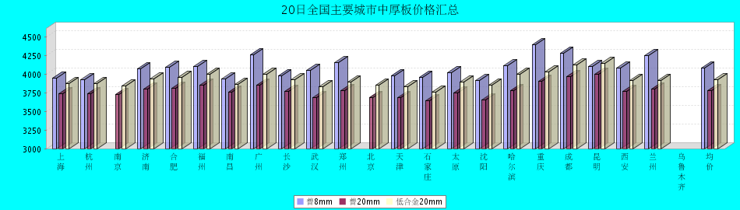
普8mm价格走势图
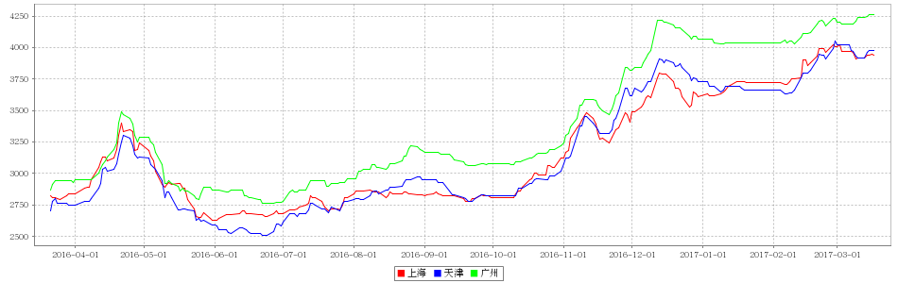
普20mm价格走势图
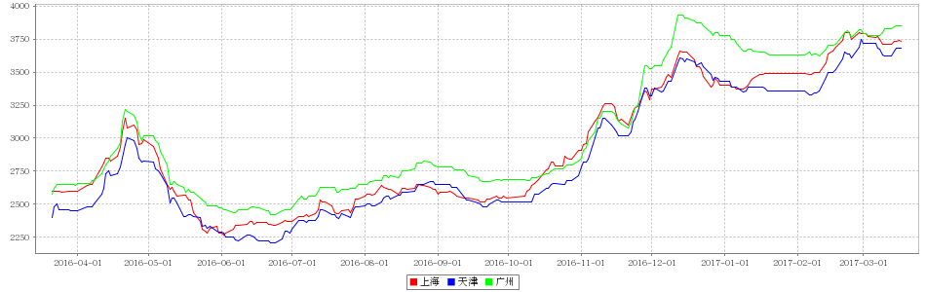
低合金20mm价格走势图
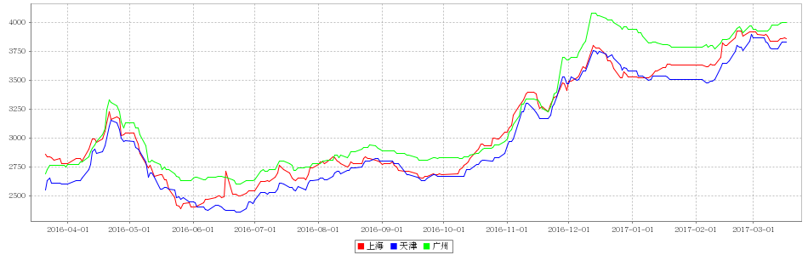

20日全国主要城市焊管价格汇总
查看历史数据2017-03-20 11:15 来源：我的钢铁 资讯监督 用手机看行情
分享到：新浪微博QQ空间腾讯微博微信打印更多3
直缝焊管 | 上海 | 杭州 | 南京 | 济南 | 合肥 | 福州 | 南昌 | 北京 | 天津 | 唐山 | 邯郸 | 包头 | 太原 | 广州 | 南宁 | 长沙 | 武汉 | 郑州 | 沈阳 | 长春 | 哈尔滨 | 重庆 | 成都 | 昆明 | 西安 | 兰州 | 乌鲁木齐 | 平均价
1.5寸*3.25 | 3820 | 3970 | 3950 | 3780 | 3800 | 4160 | 4030 | 3770 | 3650 | 3620 | 3760 | 3660 | 3720 | 4000 | 4100 | 4100 | 3920 | 3810 | 3750 | 3770 | 3700 | 4190 | 4160 | 4220 | 3930 | 4170 | 4350 | 3921
涨幅 | 0 | 0 | 0 | 0 | 0 | 0 | 0 | -20 | -10 | 0 | 0 | -20 | 0 | 0 | 0 | -30 | -30 | 0 | 0 | 0 | 0 | 0 | 0 | 0 | 0 | 0 | 0 | -4
产地 | 衡水华岐 | 衡水华岐 | 衡水华岐 | 友发/京华 | 天津友发 | 福建辉源 | 天津友发 | 京华 | 友发 | 友发 | 正大/友发 | 友发 | 友发 | 佛山振鸿 | 南宁蓝天 | 邯郸友发 | 正大 | 邯郸正大 | 雷明 | 吉林华歧 | 吉林华岐 | 成都华岐 | 成都华岐 | 通海方圆 | 友发 | 友发 | 八钢 | -
 | 现货 | 现货 | 现货 | 现货 | 现货 | 现货 | 现货 | 现货 | 现货 | 现货 | 现货 | 现货 | 现货 | 现货 | 现货 | 现货 | 现货 | 现货 | 现货 | 现货 | 现货 | 现货 | 现货 | 现货 | 现货 | 现货 | 现货
4寸*3.75 | 3870 | 3920 | 3900 | 3770 | 3770 | 4160 | 3960 | 3700 | 3640 | 3600 | 3710 | 3600 | 3710 | 4050 | 4200 | 4070 | 3900 | 3750 | 3750 | 3770 | 3700 | 4180 | 4150 | 4200 | 3850 | 4070 | 4250 | 3896
涨幅 | 0 | 0 | 0 | 0 | 0 | 0 | 0 | -20 | -10 | 0 | 0 | -20 | 0 | 0 | 0 | -30 | -30 | 0 | 0 | 0 | 0 | 0 | 0 | 0 | 0 | 0 | 0 | -4
产地 | 天津君诚 | 衡水华岐 | 衡水华岐 | 友发/京华 | 天津友发 | 福建辉源 | 天津友发 | 增洲 | 友发 | 增洲 | 正大/友发 | 友发 | 友发 | 佛山振鸿 | 佛山振鸿 | 邯郸友发 | 正大 | 邯郸正大 | 雷明 | 吉林华歧 | 吉林华岐 | 成都华岐 | 成都华岐 | 通海方圆 | 友发 | 友发 | 八钢 | -
 | 现货 | 现货 | 现货 | 现货 | 现货 | 现货 | 现货 | 现货 | 现货 | 现货 | 现货 | 现货 | 现货 | 现货 | 现货 | 现货 | 现货 | 现货 | 现货 | 现货 | 现货 | 现货 | 现货 | 现货 | 现货 | 现货 | 现货
备注 | 过磅 | 过磅 | 过磅 | 过磅 | 过磅 | 过磅 | 过磅 | 过磅 | 过磅 | 过磅 | 过磅 | 过磅 | 过磅 | 过磅 | 过磅 | 过磅 | 过磅 | 过磅 | 过磅 | 过磅 | 过磅 | 过磅 | 过磅 | 过磅 | 过磅 | 过磅 | 过磅 | -
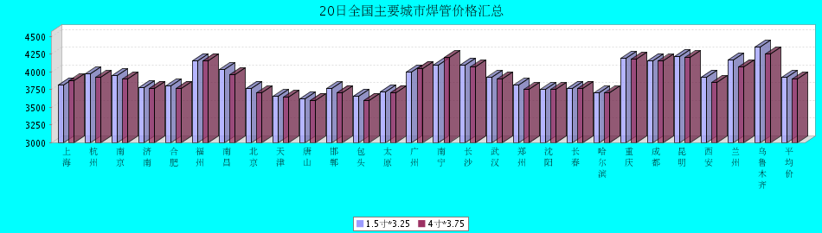

20日全国主要城市H型钢价格汇总
查看历史数据2017-03-20 11:28 来源：我的钢铁 资讯监督 用手机看行情
分享到：新浪微博QQ空间腾讯微博微信打印更多0
H型钢 | 上海 | 北京 | 天津 | 杭州 | 无锡 | 唐山 | 济南 | 太原 | 福州 | 成都 | 郑州 | 西安 | 鞍山 | 广州 | 均价
200*100 | 3530 | 3400 | 3420 | 3610 | 3490 | 3410 | 3460 | 3570 | 3750 | 3880 | - | 3980 | 3620 | 3650 | 3598
涨跌 | +10 | -20 | -20 | 0 | 0 | -20 | -40 | 0 | 0 | 0 | - | 0 | 0 | 0 | -7
产地 | 马钢 | 莱\日 | 莱\日 | 马钢 | 莱钢 | 莱\日 | 津西 | 莱钢 | 日照 | 莱钢 | - | 莱钢 | 津西 | 津西 | -
 | 现货 | 现货 | 现货 | 现货 | 现货 | 现货 | 现货 | 现货 | 现货 | 现货 | 现货 | 现货 | 现货 | 现货
300*300 | 3590 | 3500 | 3470 | 3690 | 3590 | 3480 | 3590 | 3720 | 3950 | 3890 | 3610 | 3960 | 3720 | 3850 | 3686
涨跌 | +10 | -20 | -20 | 0 | 0 | -20 | -40 | 0 | 0 | 0 | 0 | 0 | 0 | 0 | -7
产地 | 马钢 | 马\莱 | 马\莱 | 马钢 | 马钢 | 津西 | 津西 | 莱钢 | 日照 | 马钢 | 莱钢 | 莱钢 | 津西 | 马钢 | -
 | 现货 | 现货 | 现货 | 现货 | 现货 | 现货 | 现货 | 现货 | 现货 | 现货 | 现货 | 现货 | 现货 | 现货
400*200 | 3630 | 3520 | 3470 | 3610 | 3600 | 3510 | 3570 | 3720 | 3800 | 3940 | 3600 | 3820 | 3680 | 3760 | 3659
涨跌 | +10 | -20 | -20 | 0 | 0 | -20 | -40 | 0 | 0 | 0 | 0 | 0 | 0 | 0 | -7
产地 | 马钢 | 莱\津 | 莱\津 | 莱钢 | 莱钢 | 津西 | 津西 | 长治 | 日照 | 莱钢 | 莱钢 | 首钢长治 | 津西 | 马钢 | -
 | 现货 | 现货 | 现货 | 现货 | 现货 | 现货 | 现货 | 现货 | 现货 | 现货 | 现货 | 现货 | 现货 | 现货
588*300 | 3610 | 3520 | 3460 | 3780 | 3590 | 3500 | 3580 | 3690 | 3950 | 3880 | 3600 | 4090 | 3720 | 3830 | 3700
涨跌 | +10 | -20 | -20 | 0 | 0 | -20 | -40 | 0 | 0 | 0 | 0 | 0 | 0 | 0 | -6
产地 | 马钢 | 莱\津 | 莱\津 | 马钢 | 莱钢 | 津西 | 津西 | 莱钢 | 日照 | 马钢 | 莱钢 | 莱钢 | 津西 | 津西 | -
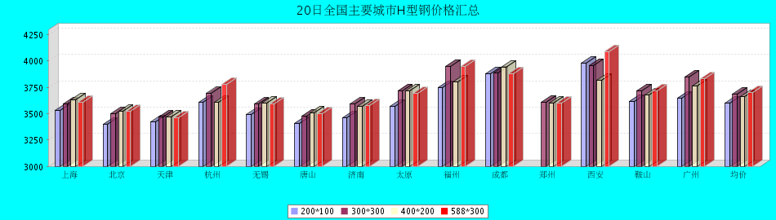

20日全国主要城市工角槽钢价格汇总
查看历史数据2017-03-20 11:40 来源：我的钢铁 资讯监督 用手机看行情
分享到：新浪微博QQ空间腾讯微博微信打印更多0
型材 | 上海 | 杭州 | 南京 | 济南 | 合肥 | 福州 | 南昌 | 广州 | 长沙 | 武汉 | 郑州 | 北京 | 天津 | 石家庄 | 太原 | 沈阳 | 哈尔滨 | 重庆 | 成都 | 昆明 | 西安 | 兰州 | 乌鲁木齐 | 均价
50*5角钢 | 3830 | 3920 | 3910 | 3740 | 3900 | 4050 | 3830 | 3930 | 4210 | 3920 | 3970 | 3390 | 3430 | 3480 | 3830 | 3880 | 3990 | 4020 | 4100 | 4480 | 3780 | 3880 | 3910 | 3886
涨跌 | 0 | +10 | 0 | +40 | 0 | 0 | 0 | 0 | +10 | 0 | 0 | +20 | +20 | 0 | 0 | 0 | 0 | 0 | 0 | 0 | 0 | +50 | 0 | +6
主导钢厂 | 马钢 | 马钢 | 马钢 | 安钢 | 马钢 | 唐山正丰 | 南钢 | 冀丰 | 安钢 | 安钢 | 安钢 | 首钢 | 兆博 | 唐山 | 唐山正丰 | 唐山正丰 | 唐山正丰 | 安阳 | 安阳 | 安钢 | 安钢 | 安钢 | 八钢 | -
 | 现货 | 现货 | 现货 | 现货 | 现货 | 现货 | 现货 | 现货 | 现货 | 现货 | 现货 | 现货 | 现货 | 现货 | 现货 | 现货 | 现货 | 现货 | 现货 | 现货 | 现货 | 现货 | 现货
16＃槽钢 | 3790 | 3860 | 3870 | 3760 | 3830 | 4050 | 3800 | 3930 | 4230 | 3930 | 4030 | 3470 | 3410 | 3450 | 3830 | 3620 | 3770 | 3850 | 3800 | 4400 | 3900 | 4100 | 3920 | 3852
涨跌 | 0 | +10 | 0 | +40 | 0 | 0 | 0 | 0 | 0 | 0 | -30 | +20 | -50 | -40 | 0 | 0 | 0 | 0 | 0 | 0 | 0 | +50 | 0 | 0
主导钢厂 | 马钢 | 马钢 | 马钢 | 济钢 | 马钢 | 唐山鑫诚 | 马钢 | 柳钢 | 东山冶金 | 马钢 | 济钢 | 中德 | 江天 | 唐山 | 唐山瑞隆 | 鞍山宝得 | 鞍山宝得 | 东山 | 东山 | 河北东山 | 河北东山 | 鞍山宝得 | 八钢 | -
 | 现货 | 现货 | 现货 | 现货 | 现货 | 现货 | 现货 | 现货 | 现货 | 现货 | 现货 | 现货 | 现货 | 现货 | 现货 | 现货 | 现货 | 现货 | 现货 | 现货 | 现货 | 现货 | 现货
25＃工字钢 | 3860 | 4020 | 3910 | 3840 | 3930 | 4100 | 3990 | 4280 | 4180 | 4070 | 3800 | 3450 | 3430 | 3480 | 3830 | 3560 | 3700 | 3980 | 3950 | 4300 | 4210 | 4130 | 4270 | 3925
涨跌 | 0 | 0 | 0 | +40 | 0 | +50 | 0 | 0 | 0 | -20 | 0 | +20 | 0 | 0 | 0 | 0 | 0 | 0 | 0 | 0 | 0 | +50 | 0 | +6
主导钢厂 | 莱钢 | 莱钢 | 莱钢 | 莱钢 | 武钢 | 日照 | 莱钢 | 日照 | 莱钢 | 包钢 | 莱钢 | 津西 | 唐山 | 唐山 | 唐山弘泰 | 东四 | 宝得 | 日照 | 日照 | 日照 | 日照 | 莱钢 | 海城 | -
 | 现货 | 现货 | 现货 | 现货 | 现货 | 现货 | 现货 | 现货 | 现货 | 现货 | 现货 | 现货 | 现货 | 现货 | 现货 | 现货 | 现货 | 现货 | 现货 | 现货 | 现货 | 现货 | 现货
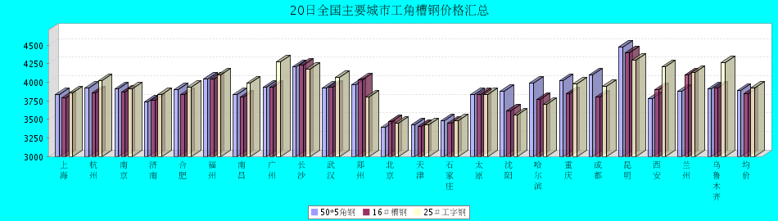

20日全国主要城市镀锌管价格汇总
查看历史数据2017-03-20 11:15 来源：我的钢铁 资讯监督 用手机看行情
分享到：新浪微博QQ空间腾讯微博微信打印更多0
镀锌焊管 | 上海 | 杭州 | 南京 | 济南 | 合肥 | 福州 | 南昌 | 北京 | 天津 | 唐山 | 邯郸 | 包头 | 太原 | 广州 | 南宁 | 长沙 | 武汉 | 郑州 | 沈阳 | 长春 | 哈尔滨 | 重庆 | 成都 | 昆明 | 西安 | 兰州 | 乌鲁木齐 | 平均价
1.5寸*3.25 | 4660 | 4690 | 4610 | 4690 | 4610 | 4710 | 4730 | 4690 | 4530 | 4570 | 4690 | 4390 | 4630 | 5270 | 4860 | 4900 | 4750 | 4520 | 4590 | 4400 | 4350 | 4880 | 4850 | 4880 | 4680 | 4700 | 4800 | 4690
涨幅 | 0 | 0 | 0 | 0 | 0 | 0 | 0 | 0 | 0 | 0 | 0 | 0 | 0 | 0 | 0 | -30 | 0 | -50 | 0 | 0 | 0 | 0 | 0 | 0 | 0 | 0 | 0 | -3
产地 | 天津君诚 | 衡水华岐 | 衡水华岐 | 友发 | 天津友发 | 君诚 | 邯郸友发 | 利达 | 友发 | 正金元 | 邯郸友发 | 友发 | 友发 | 友发 | 天津君诚 | 邯郸友发 | 邯郸友发 | 邯郸正大 | 正金元 | 吉林华岐 | 吉林华岐 | 成都华岐 | 华歧 | 邯郸友发 | 利达 | 君诚 | 友发 | -
4寸*3.75 | 4430 | 4380 | 4380 | 4400 | 4320 | 4420 | 4460 | 4440 | 4220 | 4260 | 4400 | 4100 | 4340 | 4970 | 4620 | 4600 | 4460 | 4210 | 4250 | 4150 | 4100 | 4560 | 4560 | 4670 | 4480 | 4450 | 4750 | 4421
涨幅 | 0 | 0 | 0 | 0 | 0 | 0 | 0 | 0 | 0 | 0 | 0 | 0 | 0 | 0 | 0 | -30 | 0 | -50 | 0 | 0 | 0 | 0 | 0 | 0 | 0 | 0 | 0 | -3
产地 | 天津友发 | 天津友发 | 天津友发 | 友发 | 天津友发 | 君诚 | 邯郸友发 | 利达 | 友发 | 正金元 | 邯郸友发 | 友发 | 友发 | 友发 | 天津君诚 | 衡水华岐 | 邯郸友发 | 邯郸正大 | 正金元 | 正金元 | 吉林华岐 | 成都华岐 | 华歧 | 邯郸友发 | 利达 | 君诚 | 友发 | -
备注 | 过磅 | 过磅 | 过磅 | 过磅 | 过磅 | 过磅 | 过磅 | 过磅 | 过磅 | 过磅 | 过磅 | 过磅 | 过磅 | 过磅 | 过磅 | 过磅 | 过磅 | 过磅 | 过磅 | 过磅 | 过磅 | 过磅 | 过磅 | 过磅 | 理计 | 过磅 | 过磅 | -
