23日全国主要城市线材价格汇总
查看历史数据2017-03-23 12:11 来源：我的钢铁 资讯监督 用手机看行情
分享到：新浪微博QQ空间腾讯微博微信打印更多0
线材 | 上海 | 杭州 | 南京 | 济南 | 合肥 | 福州 | 南昌 | 广州 | 长沙 | 武汉 | 郑州 | 北京 | 天津 | 石家庄 | 太原 | 沈阳 | 哈尔滨 | 重庆 | 成都 | 贵阳 | 昆明 | 西安 | 兰州 | 乌鲁木齐 | 均价
6.5高线HPB300 | - | 3860 | 3930 | - | 4200 | 3900 | 3780 | 4230 | 3900 | 3910 | 3880 | 4030 | 3600 | - | 3840 | 3880 | 3800 | 3980 | 3990 | 4170 | 4470 | 3920 | 4000 | 3770 | 3954
涨跌 | - | -20 | -10 | - | 0 | -20 | 0 | 0 | -10 | -30 | -10 | 0 | -20 | - | -40 | 0 | -40 | -30 | -10 | -30 | 0 | 0 | 0 | 0 | -13
产地 | - | 中天 | 萍钢 | 莱钢永锋 | 马钢 | 三钢 | 南（昌）钢 | 韶钢 | 萍钢 | 鄂钢 | 信钢 | 河钢承钢 | 国义 | 邯钢 | 首钢长治 | 北台 | 西钢 | 达钢 | 达钢 | 水钢 | 昆钢 | 龙钢 | 酒钢 | 八钢 | -
 | 现货 | 现货 | 现货 | 现货 | 现货 | 现货 | 现货 | 现货 | 现货 | 现货 | 现货 | 现货 | 现货 | 现货 | 现货 | 现货 | 现货 | 现货 | 现货 | 现货 | 现货 | 现货 | 现货 | 现货
8.0高线HPB300 | 3870 | 3860 | 3930 | 3920 | 4200 | 3920 | 3780 | 4200 | 3900 | 3910 | 3880 | 3990 | 3490 | - | 3840 | 3830 | 3750 | 3930 | 3940 | 4170 | 4470 | 3870 | 3950 | 3770 | 3929
涨跌 | -20 | -20 | -10 | 0 | 0 | +30 | 0 | 0 | -10 | -30 | -10 | 0 | 0 | - | -40 | 0 | -40 | -30 | -10 | -30 | 0 | 0 | 0 | 0 | -10
产地 | 中天 | 中天 | 萍钢 | 莱钢永锋 | 马钢 | 三钢 | 南（昌）钢 | 韶钢 | 萍钢 | 鄂钢 | 信钢 | 河钢承钢 | 安丰 | 邯钢 | 首钢长治 | 北台 | 西钢 | 达钢 | 达钢 | 水钢 | 昆钢 | 龙钢 | 酒钢 | 八钢 | -
 | 现货 | 现货 | 现货 | 现货 | 现货 | 现货 | 现货 | 现货 | 现货 | 现货 | 现货 | 现货 | 现货 | 现货 | 现货 | 现货 | 现货 | 现货 | 现货 | 现货 | 现货 | 现货 | 现货 | 现货
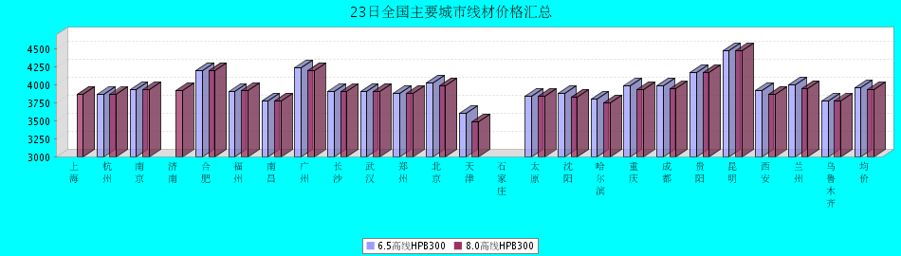
8.0高线HPB300价格走势图
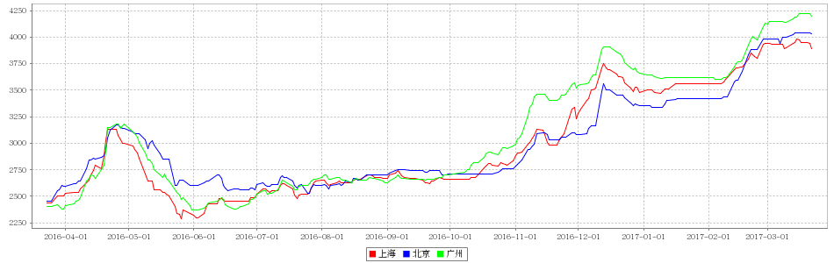
8.0高线HPB235价格走势图
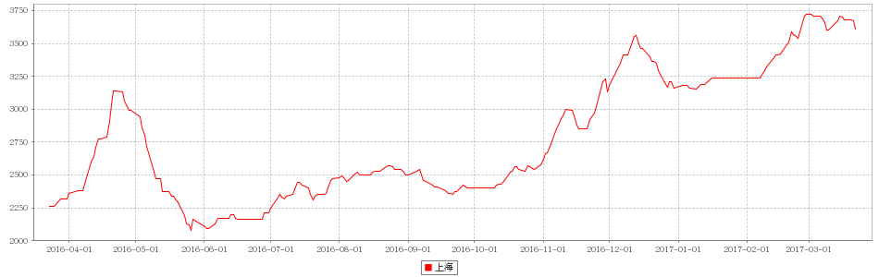

23日全国主要城市HRB400螺纹钢价格汇总
查看历史数据2017-03-23 12:11 来源：我的钢铁 资讯监督 用手机看行情
分享到：新浪微博QQ空间腾讯微博微信打印更多0
螺纹钢 | 上海 | 杭州 | 南京 | 济南 | 合肥 | 福州 | 南昌 | 南宁 | 广州 | 长沙 | 武汉 | 郑州 | 北京 | 天津 | 石家庄 | 太原 | 沈阳 | 哈尔滨 | 重庆 | 成都 | 贵阳 | 昆明 | 西安 | 兰州 | 乌鲁木齐 | 均价
HRB400 12MM | 3810 | 3770 | 3980 | 3970 | 4200 | 3840 | 3780 | 4120 | 4450 | 4170 | 3820 | 4040 | 3700 | 3780 | 3880 | 3910 | 3860 | 3800 | 4000 | 4030 | 4300 | 4580 | 3830 | 4020 | 4040 | 3987
涨幅 | -20 | -30 | -10 | -30 | 0 | -20 | 0 | -30 | 0 | -10 | -30 | -20 | 0 | -20 | -10 | -40 | 0 | 0 | -30 | -30 | -30 | 0 | -70 | -20 | 0 | -18
产地 | 申特 | 中天 | 永钢 | 莱钢 | 马钢 | 三钢 | 南(昌)钢 | 柳钢 | 韶钢 | 涟钢 | 新兴铸管 | 安钢 | 河钢承钢 | 河钢承钢 | 邯钢 | 首钢长治 | 新抚钢 | 西钢 | 达钢 | 威钢 | 水钢 | 昆钢 | 龙钢 | 酒钢 | 八钢 | -
计重方式 | 理计 | 理计 | 理计 | 理计 | 理计 | 理计 | 理计 | 理计 | 过磅 | 过磅 | 理计 | 理计 | 理计 | 理计 | 理计 | 理计 | 理计 | 理计 | 过磅 | 过磅 | 过磅 | 理计 | 理计 | 理计 | 理计 | -
30天均价 | 3870 | 3866 | 4017 | 4041 | 4172 | 3910 | 3834 | 4225 | 4377 | 4277 | 3887 | 4108 | 3770 | 3794 | 3984 | 3916 | 3780 | 3752 | 4134 | 4203 | 4257 | 4557 | 3865 | 4116 | 4006 | 4029
 | 现货 | 现货 | 现货 | 现货 | 现货 | 现货 | 现货 | 现货 | 现货 | 现货 | 现货 | 现货 | 现货 | 现货 | 现货 | 现货 | 现货 | 现货 | 现货 | 现货 | 现货 | 现货 | 现货 | 现货 | 现货
HRB400 20MM | 3660 | 3640 | 3820 | 3850 | 4080 | 3720 | 3660 | 3970 | 4260 | 3970 | 3670 | 3890 | 3670 | 3660 | 3850 | 3810 | 3710 | 3690 | 3850 | 3850 | 4150 | 4390 | 3750 | 3820 | 3790 | 3847
涨幅 | -20 | -20 | -10 | -30 | 0 | -20 | 0 | -30 | 0 | -10 | -30 | -20 | 0 | -20 | 0 | -40 | 0 | 0 | -30 | -30 | -30 | 0 | -30 | -20 | 0 | -16
产地 | 中天 | 中天 | 沙钢 | 莱钢 | 马钢 | 三钢 | 南(昌)钢 | 柳钢 | 韶钢 | 涟钢 | 萍钢 | 安钢 | 河钢承钢 | 河钢承钢 | 邯钢 | 首钢长治 | 新抚钢 | 西钢 | 达钢 | 威钢 | 水钢 | 昆钢 | 龙钢 | 酒钢 | 八钢 | -
计重方式 | 理计 | 理计 | 理计 | 理计 | 理计 | 理计 | 理计 | 理计 | 过磅 | 过磅 | 理计 | 理计 | 理计 | 理计 | 理计 | 理计 | 理计 | 理计 | 过磅 | 过磅 | 过磅 | 理计 | 理计 | 理计 | 理计 | -
30天均价 | 3723 | 3726 | 3851 | 3921 | 4054 | 3776 | 3715 | 4071 | 4167 | 4077 | 3740 | 3992 | 3784 | 3778 | 3924 | 3816 | 3650 | 3642 | 3984 | 3996 | 4107 | 4344 | 3746 | 3918 | 3756 | 3890
 | 现货 | 现货 | 现货 | 现货 | 现货 | 现货 | 现货 | 现货 | 现货 | 现货 | 现货 | 现货 | 现货 | 现货 | 现货 | 现货 | 现货 | 现货 | 现货 | 现货 | 现货 | 现货 | 现货 | 现货 | 现货
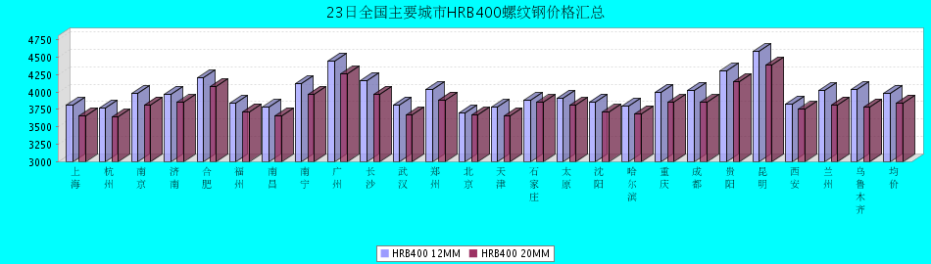
HRB400螺纹钢12MM价格走势图

HRB400螺纹钢20MM价格走势图
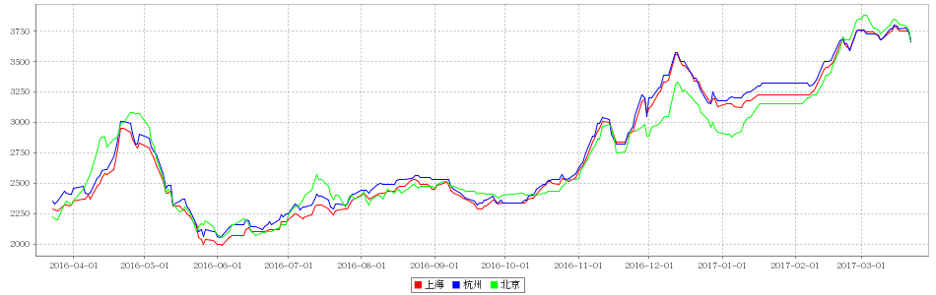

23日全国主要城市盘螺价格汇总
查看历史数据2017-03-23 12:11 来源：我的钢铁 资讯监督 用手机看行情
分享到：新浪微博QQ空间腾讯微博微信打印更多0
盘螺 | 上海 | 杭州 | 南京 | 济南 | 合肥 | 福州 | 南昌 | 南宁 | 广州 | 长沙 | 武汉 | 郑州 | 北京 | 天津 | 石家庄 | 太原 | 沈阳 | 哈尔滨 | 重庆 | 成都 | 贵阳 | 昆明 | 西安 | 兰州 | 乌鲁木齐 | 全国均价
HRB400(E) 8mm | 3880 | 3870 | 4010 | 3950 | 4260 | 4020 | 3860 | 4110 | 4410 | 4000 | 3930 | 4030 | 3750 | 3750 | 3970 | 3910 | 3940 | 3870 | 4000 | 4030 | 4290 | 4580 | 3900 | 4050 | 3900 | 4011
涨跌 | -20 | -20 | -20 | 0 | 0 | -20 | 0 | -30 | 0 | -10 | -30 | -10 | -10 | -40 | 0 | -40 | 0 | -40 | -30 | -10 | -30 | 0 | -30 | 0 | 0 | -15
产地 | 中天 | 中天 | 永钢 | 莱钢永锋 | 马钢 | 三钢 | 南（昌）钢 | 柳钢 | 韶钢 | 湘钢 | 鄂钢 | 济源 | 河钢承钢 | 河钢唐钢 | 邯钢 | 首钢长治 | 新抚钢 | 西林 | 水钢 | 威钢 | 水钢 | 昆钢 | 龙钢 | 酒钢 | 八钢 | -
 | 现货 | 现货 | 现货 | 现货 | 现货 | 现货 | 现货 | 现货 | 现货 | 现货 | 现货 | 现货 | 现货 | 现货 | 现货 | 现货 | 现货 | 现货 | 现货 | 现货 | 现货 | 现货 | 现货 | 现货 | 现货
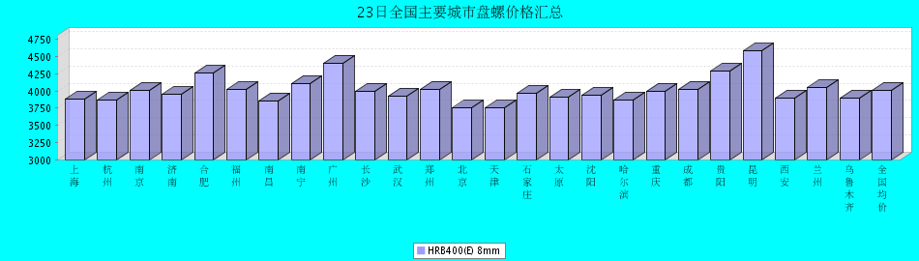

23日全国主要城市中厚板价格汇总
查看历史数据2017-03-23 11:56 来源：我的钢铁 资讯监督 用手机看行情
分享到：新浪微博QQ空间腾讯微博微信打印更多0
中板 | 上海 | 杭州 | 南京 | 济南 | 合肥 | 福州 | 南昌 | 广州 | 长沙 | 武汉 | 郑州 | 北京 | 天津 | 石家庄 | 太原 | 沈阳 | 哈尔滨 | 重庆 | 成都 | 昆明 | 西安 | 兰州 | 乌鲁木齐 | 均价
普8mm | 3890 | 3850 | - | 4000 | 4060 | 4030 | 3850 | 4220 | 3930 | 3970 | 4090 | - | 3900 | 3890 | 3930 | 3860 | 4080 | 4330 | 4230 | 4030 | 3990 | 4230 | 4270 | 4030
涨跌 | 0 | 0 | - | -70 | 0 | -20 | -10 | -20 | -30 | -30 | -20 | - | -10 | -30 | -30 | -20 | 0 | -20 | -10 | -20 | -40 | -20 | -10 | -20
产地 | 萍钢 | 萍钢 | 萍钢 | 济钢 | 马钢 | 三钢 | 新余 | 韶钢 | 新余 | 邯钢 | 邯钢 | - | 天钢 | 邯钢 | 太钢 | 鞍钢 | 鞍钢 | 重钢 | 酒钢 | 柳钢 | 酒钢 | 酒钢 | 八钢 | -
 | 现货 | 现货 | 现货 | 现货 | 现货 | 现货 | 现货 | 现货 | 现货 | 现货 | 现货 | 现货 | 现货 | 现货 | 现货 | 现货 | 现货 | 现货 | 现货 | 现货 | 现货 | 现货 | 现货
普20mm | 3650 | 3670 | 3670 | 3730 | 3780 | 3780 | 3680 | 3810 | 3720 | 3600 | 3720 | 3610 | 3600 | 3570 | 3660 | 3600 | 3750 | 3840 | 3920 | 3950 | 3680 | 3780 | 4000 | 3729
涨跌 | -30 | 0 | -10 | -70 | 0 | -20 | -10 | -20 | -30 | -30 | -20 | -20 | -10 | -30 | -30 | -20 | 0 | -20 | -10 | -20 | -40 | -20 | -10 | -21
产地 | 萍钢 | 萍钢 | 萍钢 | 济钢 | 马钢 | 三钢 | 新余 | 韶钢 | 湘钢 | 鄂钢 | 安阳 | 敬业 | 天钢 | 敬业 | 文丰 | 鞍钢 | 鞍钢 | 重钢 | 酒钢 | 柳钢 | 酒钢 | 酒钢 | 八钢 | -
 | 现货 | 现货 | 现货 | 现货 | 现货 | 现货 | 现货 | 现货 | 现货 | 现货 | 现货 | 现货 | 现货 | 现货 | 现货 | 现货 | 现货 | 现货 | 现货 | 现货 | 现货 | 现货 | 现货
低合金20mm | 3780 | 3800 | 3780 | 3860 | 3930 | 3930 | 3780 | 3960 | 3870 | 3740 | 3830 | 3770 | 3750 | 3680 | 3800 | 3800 | 3970 | 3970 | 4070 | 4090 | 3820 | 3890 | 4120 | 3869
涨跌 | -30 | 0 | -90 | -70 | 0 | -20 | -10 | -20 | -30 | -40 | -20 | -20 | -10 | -30 | -30 | -20 | 0 | -20 | -10 | -20 | -40 | -20 | -10 | -24
产地 | 萍钢 | 萍钢 | 萍钢 | 济钢 | 马钢 | 三钢 | 新余 | 韶钢 | 湘钢 | 鄂钢 | 安阳 | 敬业 | 天钢 | 敬业 | 文丰 | 鞍钢 | 鞍钢 | 重钢 | 酒钢 | 韶钢 | 酒钢 | 酒钢 | 八钢 | -
 | 现货 | 现货 | 现货 | 现货 | 现货 | 现货 | 现货 | 现货 | 现货 | 现货 | 现货 | 现货 | 现货 | 现货 | 现货 | 现货 | 现货 | 现货 | 现货 | 现货 | 现货 | 现货 | 现货
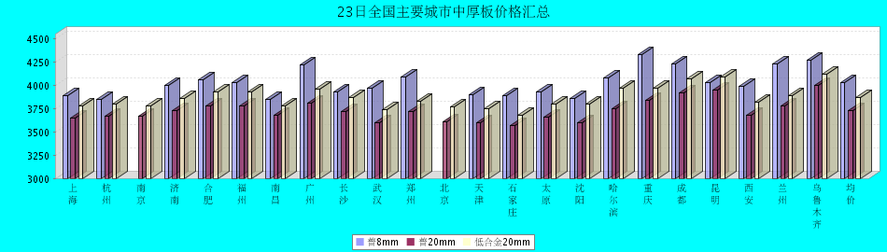
普8mm价格走势图
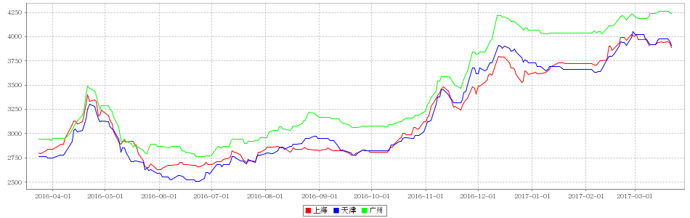
普20mm价格走势图
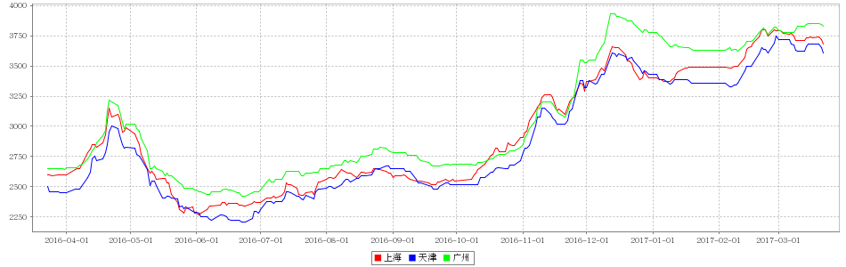
低合金20mm价格走势图
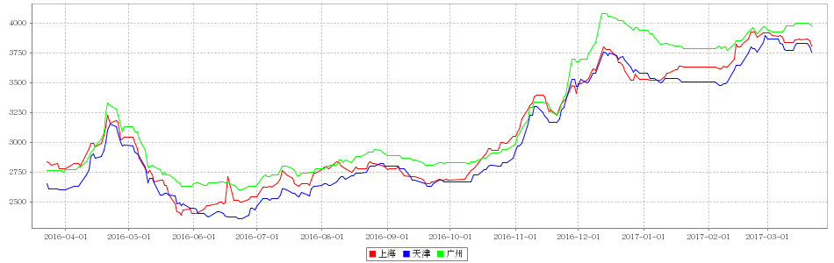

23日全国主要城市焊管价格汇总
查看历史数据2017-03-23 11:30 来源：我的钢铁 资讯监督 用手机看行情
分享到：新浪微博QQ空间腾讯微博微信打印更多0
直缝焊管 | 上海 | 杭州 | 南京 | 济南 | 合肥 | 福州 | 南昌 | 北京 | 天津 | 唐山 | 邯郸 | 包头 | 太原 | 广州 | 南宁 | 长沙 | 武汉 | 郑州 | 沈阳 | 长春 | 哈尔滨 | 重庆 | 成都 | 昆明 | 西安 | 兰州 | 乌鲁木齐 | 平均价
1.5寸*3.25 | 3790 | 3940 | 3880 | 3750 | 3830 | 4100 | 4030 | 3720 | 3570 | 3540 | 3710 | 3580 | 3690 | 3950 | 4100 | 4100 | 3900 | 3710 | 3650 | 3680 | 3600 | 4160 | 4110 | 4220 | 3850 | 4090 | 4300 | 3872
涨幅 | 0 | 0 | 0 | 0 | -50 | 0 | 0 | -50 | -50 | -50 | -30 | -60 | 0 | 0 | 0 | 0 | 0 | -100 | -50 | 0 | 0 | 0 | 0 | 0 | -80 | -80 | -50 | -24
产地 | 衡水华岐 | 衡水华岐 | 衡水华岐 | 友发/京华 | 天津友发 | 福建辉源 | 天津友发 | 京华 | 友发 | 友发 | 正大/友发 | 友发 | 友发 | 佛山振鸿 | 南宁蓝天 | 邯郸友发 | 正大 | 邯郸正大 | 雷明 | 吉林华歧 | 吉林华岐 | 成都华岐 | 成都华岐 | 通海方圆 | 友发 | 友发 | 八钢 | -
 | 现货 | 现货 | 现货 | 现货 | 现货 | 现货 | 现货 | 现货 | 现货 | 现货 | 现货 | 现货 | 现货 | 现货 | 现货 | 现货 | 现货 | 现货 | 现货 | 现货 | 现货 | 现货 | 现货 | 现货 | 现货 | 现货 | 现货
4寸*3.75 | 3850 | 3890 | 3830 | 3740 | 3800 | 4100 | 3960 | 3650 | 3550 | 3520 | 3660 | 3520 | 3680 | 3950 | 4150 | 4070 | 3880 | 3650 | 3650 | 3680 | 3600 | 4150 | 4100 | 4200 | 3770 | 3990 | 4200 | 3844
涨幅 | 0 | 0 | 0 | 0 | -50 | 0 | 0 | -50 | -50 | -50 | -30 | -60 | 0 | 0 | 0 | 0 | 0 | -100 | -50 | 0 | 0 | 0 | 0 | 0 | -80 | -80 | -50 | -24
产地 | 天津君诚 | 衡水华岐 | 衡水华岐 | 友发/京华 | 天津友发 | 福建辉源 | 天津友发 | 增洲 | 友发 | 增洲 | 正大/友发 | 友发 | 友发 | 佛山振鸿 | 佛山振鸿 | 邯郸友发 | 正大 | 邯郸正大 | 雷明 | 吉林华歧 | 吉林华岐 | 成都华岐 | 成都华岐 | 通海方圆 | 友发 | 友发 | 八钢 | -
 | 现货 | 现货 | 现货 | 现货 | 现货 | 现货 | 现货 | 现货 | 现货 | 现货 | 现货 | 现货 | 现货 | 现货 | 现货 | 现货 | 现货 | 现货 | 现货 | 现货 | 现货 | 现货 | 现货 | 现货 | 现货 | 现货 | 现货
备注 | 过磅 | 过磅 | 过磅 | 过磅 | 过磅 | 过磅 | 过磅 | 过磅 | 过磅 | 过磅 | 过磅 | 过磅 | 过磅 | 过磅 | 过磅 | 过磅 | 过磅 | 过磅 | 过磅 | 过磅 | 过磅 | 过磅 | 过磅 | 过磅 | 过磅 | 过磅 | 过磅 | -
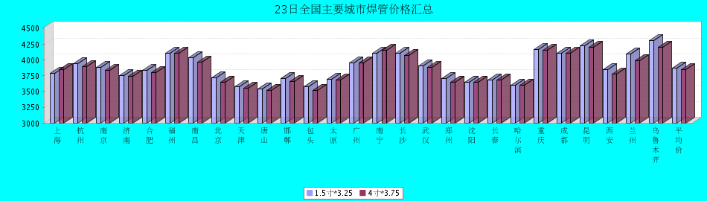

23日全国主要城市H型钢价格汇总
查看历史数据2017-03-23 11:56 来源：我的钢铁 资讯监督 用手机看行情
分享到：新浪微博QQ空间腾讯微博微信打印更多0
H型钢 | 上海 | 北京 | 天津 | 杭州 | 无锡 | 唐山 | 济南 | 太原 | 福州 | 成都 | 郑州 | 西安 | 鞍山 | 广州 | 均价
200*100 | 3430 | 3340 | 3350 | 3590 | 3450 | 3310 | 3400 | 3570 | 3600 | 3820 | - | 3830 | 3520 | 3620 | 3525
涨跌 | 0 | -30 | -40 | 0 | -40 | -30 | -20 | 0 | -50 | -20 | - | -150 | -30 | -30 | -34
产地 | 马钢 | 莱\日 | 莱\日 | 马钢 | 莱钢 | 莱\日 | 津西 | 莱钢 | 日照 | 莱钢 | - | 莱钢 | 津西 | 津西 | -
 | 现货 | 现货 | 现货 | 现货 | 现货 | 现货 | 现货 | 现货 | 现货 | 现货 | 现货 | 现货 | 现货 | 现货
300*300 | 3510 | 3440 | 3400 | 3670 | 3550 | 3420 | 3530 | 3720 | 3800 | 3830 | 3580 | 3810 | 3620 | 3820 | 3621
涨跌 | 0 | -30 | -40 | 0 | -40 | -30 | -20 | 0 | -50 | -20 | 0 | -150 | -30 | -30 | -32
产地 | 马钢 | 马\莱 | 马\莱 | 马钢 | 马钢 | 津西 | 津西 | 莱钢 | 日照 | 马钢 | 莱钢 | 莱钢 | 津西 | 马钢 | -
 | 现货 | 现货 | 现货 | 现货 | 现货 | 现货 | 现货 | 现货 | 现货 | 现货 | 现货 | 现货 | 现货 | 现货
400*200 | 3550 | 3460 | 3400 | 3590 | 3560 | 3430 | 3510 | 3720 | 3650 | 3880 | 3570 | 3670 | 3580 | 3730 | 3593
涨跌 | 0 | -30 | -40 | 0 | -40 | -30 | -20 | 0 | -50 | -20 | 0 | -150 | -30 | -30 | -31
产地 | 马钢 | 莱\津 | 莱\津 | 莱钢 | 莱钢 | 津西 | 津西 | 长治 | 日照 | 莱钢 | 莱钢 | 首钢长治 | 津西 | 马钢 | -
 | 现货 | 现货 | 现货 | 现货 | 现货 | 现货 | 现货 | 现货 | 现货 | 现货 | 现货 | 现货 | 现货 | 现货
588*300 | 3530 | 3460 | 3390 | 3760 | 3550 | 3400 | 3520 | 3690 | 3800 | 3820 | 3570 | 3940 | 3620 | 3800 | 3632
涨跌 | 0 | -30 | -40 | 0 | -40 | -30 | -20 | 0 | -50 | -20 | 0 | -150 | -30 | -30 | -32
产地 | 马钢 | 莱\津 | 莱\津 | 马钢 | 莱钢 | 津西 | 津西 | 莱钢 | 日照 | 马钢 | 莱钢 | 莱钢 | 津西 | 津西 | -
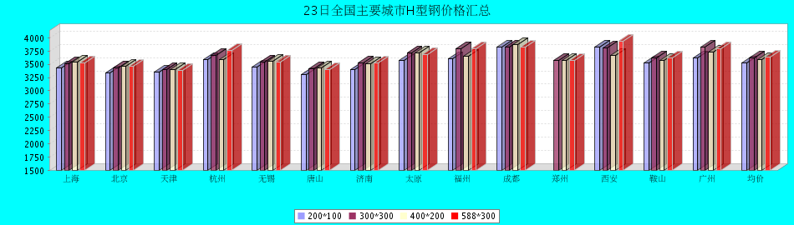

23日全国主要城市工角槽钢价格汇总
查看历史数据2017-03-23 11:54 来源：我的钢铁 资讯监督 用手机看行情
分享到：新浪微博QQ空间腾讯微博微信打印更多0
型材 | 上海 | 杭州 | 南京 | 济南 | 合肥 | 福州 | 南昌 | 广州 | 长沙 | 武汉 | 郑州 | 北京 | 天津 | 石家庄 | 太原 | 沈阳 | 哈尔滨 | 重庆 | 成都 | 昆明 | 西安 | 兰州 | 乌鲁木齐 | 均价
50*5角钢 | 3780 | 3900 | 3870 | 3720 | 3860 | 3950 | 3830 | 3880 | 4160 | 3860 | 3900 | 3320 | 3280 | 3400 | 3720 | 3790 | 3890 | 4050 | 4080 | 4430 | 3730 | 3810 | 3910 | 3831
涨跌 | -30 | 0 | -20 | 0 | -20 | +50 | 0 | -50 | 0 | -30 | -20 | -30 | -20 | -10 | -50 | -40 | -40 | 0 | 0 | 0 | -30 | -70 | 0 | -18
主导钢厂 | 马钢 | 马钢 | 马钢 | 安钢 | 马钢 | 唐山正丰 | 南钢 | 冀丰 | 安钢 | 安钢 | 安钢 | 首钢 | 兆博 | 唐山 | 唐山正丰 | 唐山正丰 | 唐山正丰 | 安阳 | 安阳 | 安钢 | 安钢 | 安钢 | 八钢 | -
 | 现货 | 现货 | 现货 | 现货 | 现货 | 现货 | 现货 | 现货 | 现货 | 现货 | 现货 | 现货 | 现货 | 现货 | 现货 | 现货 | 现货 | 现货 | 现货 | 现货 | 现货 | 现货 | 现货
16＃槽钢 | 3740 | 3840 | 3830 | 3740 | 3790 | 3950 | 3800 | 3860 | 4080 | 3870 | 3890 | 3400 | 3280 | 3310 | 3680 | 3540 | 3690 | 3790 | 3720 | 4330 | 3780 | 4030 | 3920 | 3777
涨跌 | -30 | 0 | -20 | 0 | -20 | +50 | 0 | -50 | -20 | -30 | -40 | -30 | 0 | 0 | 0 | -40 | -40 | -10 | 0 | -40 | -100 | -70 | 0 | -21
主导钢厂 | 马钢 | 马钢 | 马钢 | 济钢 | 马钢 | 唐山鑫诚 | 马钢 | 柳钢 | 东山冶金 | 马钢 | 济钢 | 中德 | 江天 | 唐山 | 唐山瑞隆 | 鞍山宝得 | 鞍山宝得 | 东山 | 东山 | 河北东山 | 河北东山 | 鞍山宝得 | 八钢 | -
 | 现货 | 现货 | 现货 | 现货 | 现货 | 现货 | 现货 | 现货 | 现货 | 现货 | 现货 | 现货 | 现货 | 现货 | 现货 | 现货 | 现货 | 现货 | 现货 | 现货 | 现货 | 现货 | 现货
25＃工字钢 | 3730 | 4000 | 3830 | 3820 | 3890 | 4000 | 3990 | 4210 | 4140 | 4000 | 3730 | 3380 | 3350 | 3400 | 3730 | 3440 | 3590 | 3910 | 3890 | 4230 | 4090 | 4060 | 4270 | 3856
涨跌 | -30 | 0 | -20 | 0 | -20 | +50 | 0 | -50 | 0 | -20 | -20 | -30 | -30 | -30 | -50 | -40 | -40 | -10 | -10 | -40 | -100 | -70 | 0 | -24
主导钢厂 | 莱钢 | 莱钢 | 莱钢 | 莱钢 | 武钢 | 日照 | 莱钢 | 日照 | 莱钢 | 包钢 | 莱钢 | 津西 | 唐山 | 唐山 | 唐山弘泰 | 东四 | 宝得 | 日照 | 日照 | 日照 | 日照 | 莱钢 | 海城 | -
 | 现货 | 现货 | 现货 | 现货 | 现货 | 现货 | 现货 | 现货 | 现货 | 现货 | 现货 | 现货 | 现货 | 现货 | 现货 | 现货 | 现货 | 现货 | 现货 | 现货 | 现货 | 现货 | 现货
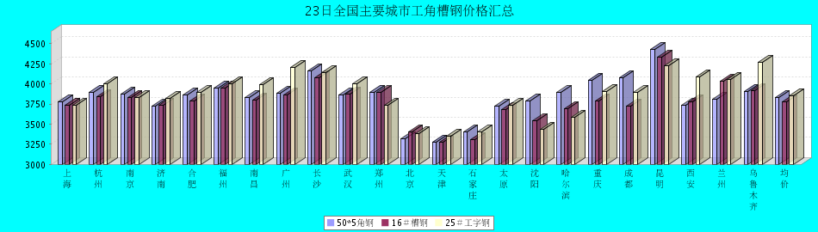

23日全国主要城市镀锌管价格汇总
查看历史数据2017-03-23 11:50 来源：我的钢铁 资讯监督 用手机看行情
分享到：新浪微博QQ空间腾讯微博微信打印更多0
镀锌焊管 | 上海 | 杭州 | 南京 | 济南 | 合肥 | 福州 | 南昌 | 北京 | 天津 | 唐山 | 邯郸 | 包头 | 太原 | 广州 | 南宁 | 长沙 | 武汉 | 郑州 | 沈阳 | 长春 | 哈尔滨 | 重庆 | 成都 | 昆明 | 西安 | 兰州 | 乌鲁木齐 | 平均价
1.5寸*3.25 | 4690 | 4690 | 4530 | 4630 | 4550 | 4630 | 4680 | 4640 | 4450 | 4490 | 4640 | 4330 | 4540 | 5190 | 4810 | 4870 | 4730 | 4460 | 4460 | 4320 | 4200 | 4850 | 4800 | 4860 | 4600 | 4620 | 4750 | 4630
涨幅 | 0 | 0 | 0 | 0 | 0 | 0 | 0 | -50 | 0 | 0 | 0 | 0 | 0 | 0 | 0 | 0 | -20 | -60 | -50 | 0 | 0 | 0 | 0 | 0 | -80 | -80 | -50 | -14
产地 | 天津君诚 | 衡水华岐 | 衡水华岐 | 友发 | 天津友发 | 君诚 | 邯郸友发 | 利达 | 友发 | 正金元 | 邯郸友发 | 友发 | 友发 | 友发 | 天津君诚 | 邯郸友发 | 邯郸友发 | 邯郸正大 | 正金元 | 吉林华岐 | 吉林华岐 | 成都华岐 | 华歧 | 邯郸友发 | 利达 | 君诚 | 友发 | -
4寸*3.75 | 4400 | 4380 | 4320 | 4340 | 4260 | 4340 | 4410 | 4390 | 4140 | 4180 | 4350 | 4040 | 4250 | 4890 | 4570 | 4570 | 4440 | 4150 | 4120 | 4070 | 3950 | 4530 | 4510 | 4650 | 4400 | 4370 | 4700 | 4360
涨幅 | 0 | 0 | 0 | 0 | 0 | 0 | 0 | -50 | 0 | 0 | 0 | 0 | 0 | 0 | 0 | 0 | -20 | -60 | -50 | 0 | 0 | 0 | 0 | 0 | -80 | -80 | -50 | -14
产地 | 天津友发 | 天津友发 | 天津友发 | 友发 | 天津友发 | 君诚 | 邯郸友发 | 利达 | 友发 | 正金元 | 邯郸友发 | 友发 | 友发 | 友发 | 天津君诚 | 衡水华岐 | 邯郸友发 | 邯郸正大 | 正金元 | 正金元 | 吉林华岐 | 成都华岐 | 华歧 | 邯郸友发 | 利达 | 君诚 | 友发 | -
备注 | 过磅 | 过磅 | 过磅 | 过磅 | 过磅 | 过磅 | 过磅 | 过磅 | 过磅 | 过磅 | 过磅 | 过磅 | 过磅 | 过磅 | 过磅 | 过磅 | 过磅 | 过磅 | 过磅 | 过磅 | 过磅 | 过磅 | 过磅 | 过磅 | 理计 | 过磅 | 过磅 | -
