31日全国主要城市线材价格汇总
查看历史数据2017-03-31 12:13 来源：我的钢铁 资讯监督 用手机看行情
分享到：新浪微博QQ空间腾讯微博微信打印更多0
线材 | 上海 | 杭州 | 南京 | 济南 | 合肥 | 福州 | 南昌 | 广州 | 长沙 | 武汉 | 郑州 | 北京 | 天津 | 石家庄 | 太原 | 沈阳 | 哈尔滨 | 重庆 | 成都 | 贵阳 | 昆明 | 西安 | 兰州 | 乌鲁木齐 | 均价
6.5高线HPB300 | - | 3840 | 3850 | - | 4080 | 3850 | 3770 | 4120 | 3810 | 3840 | 3780 | 3940 | 3510 | - | 3740 | 3630 | 3670 | 3940 | 3950 | 4030 | 4370 | 3810 | 4000 | 3730 | 3870
涨跌 | - | 0 | 0 | - | 0 | 0 | 0 | 0 | +10 | 0 | 0 | 0 | 0 | - | +20 | 0 | 0 | 0 | 0 | 0 | 0 | 0 | +50 | 0 | +4
产地 | - | 中天 | 萍钢 | 莱钢永锋 | 马钢 | 三钢 | 南（昌）钢 | 韶钢 | 萍钢 | 鄂钢 | 信钢 | 河钢承钢 | 国义 | 邯钢 | 首钢长治 | 北台 | 西钢 | 达钢 | 达钢 | 水钢 | 昆钢 | 龙钢 | 酒钢 | 八钢 | -
 | 现货 | 现货 | 现货 | 现货 | 现货 | 现货 | 现货 | 现货 | 现货 | 现货 | 现货 | 现货 | 现货 | 现货 | 现货 | 现货 | 现货 | 现货 | 现货 | 现货 | 现货 | 现货 | 现货 | 现货
8.0高线HPB300 | 3810 | 3840 | 3850 | 3760 | 4080 | 3870 | 3770 | 4090 | 3810 | 3840 | 3780 | 3900 | 3470 | - | 3740 | 3580 | 3620 | 3890 | 3900 | 4030 | 4370 | 3760 | 3950 | 3730 | 3845
涨跌 | 0 | 0 | 0 | 0 | 0 | +50 | 0 | 0 | +10 | 0 | 0 | 0 | 0 | - | +20 | 0 | 0 | 0 | 0 | 0 | 0 | 0 | 0 | 0 | +3
产地 | 中天 | 中天 | 萍钢 | 莱钢永锋 | 马钢 | 三钢 | 南（昌）钢 | 韶钢 | 萍钢 | 鄂钢 | 信钢 | 河钢承钢 | 安丰 | 邯钢 | 首钢长治 | 北台 | 西钢 | 达钢 | 达钢 | 水钢 | 昆钢 | 龙钢 | 酒钢 | 八钢 | -
 | 现货 | 现货 | 现货 | 现货 | 现货 | 现货 | 现货 | 现货 | 现货 | 现货 | 现货 | 现货 | 现货 | 现货 | 现货 | 现货 | 现货 | 现货 | 现货 | 现货 | 现货 | 现货 | 现货 | 现货
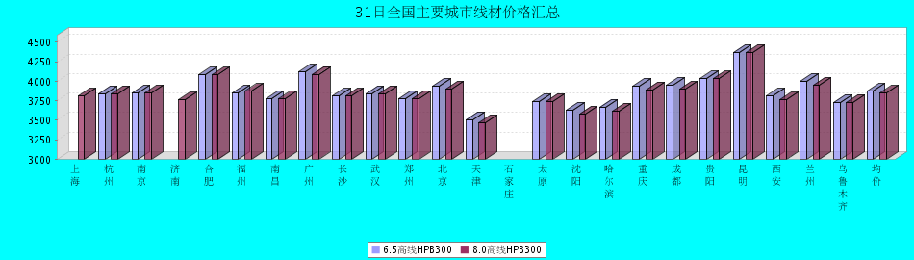
8.0高线HPB300价格走势图
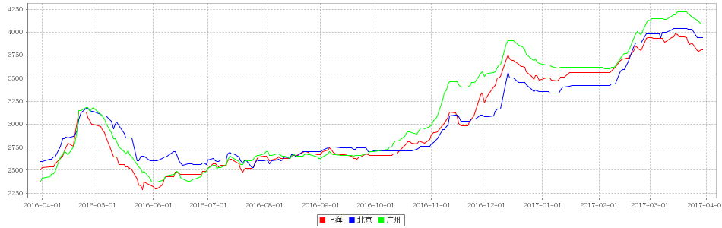
8.0高线HPB235价格走势图
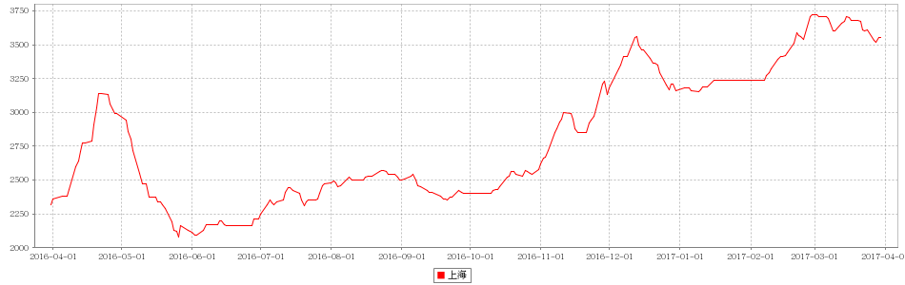

31日全国主要城市HRB400螺纹钢价格汇总
查看历史数据2017-03-31 12:13 来源：我的钢铁 资讯监督 用手机看行情
分享到：新浪微博QQ空间腾讯微博微信打印更多2
螺纹钢 | 上海 | 杭州 | 南京 | 济南 | 合肥 | 福州 | 南昌 | 南宁 | 广州 | 长沙 | 武汉 | 郑州 | 北京 | 天津 | 石家庄 | 太原 | 沈阳 | 哈尔滨 | 重庆 | 成都 | 贵阳 | 昆明 | 西安 | 兰州 | 乌鲁木齐 | 均价
HRB400 12MM | 3730 | 3750 | 3900 | 3860 | 4090 | 3790 | 3760 | 3990 | 4340 | 4120 | 3770 | 3920 | 3660 | 3710 | 3870 | 3760 | 3740 | 3670 | 3990 | 4020 | 4170 | 4480 | 3740 | 3990 | 4000 | 3913
涨幅 | 0 | 0 | 0 | 0 | 0 | 0 | 0 | 0 | -20 | +10 | 0 | 0 | 0 | +30 | 0 | +20 | 0 | 0 | 0 | 0 | 0 | 0 | 0 | +20 | 0 | +3
产地 | 申特 | 中天 | 永钢 | 莱钢 | 马钢 | 三钢 | 南(昌)钢 | 柳钢 | 韶钢 | 涟钢 | 新兴铸管 | 安钢 | 河钢承钢 | 河钢承钢 | 邯钢 | 首钢长治 | 新抚钢 | 西钢 | 达钢 | 威钢 | 水钢 | 昆钢 | 龙钢 | 酒钢 | 八钢 | -
计重方式 | 理计 | 理计 | 理计 | 理计 | 理计 | 理计 | 理计 | 理计 | 过磅 | 过磅 | 理计 | 理计 | 理计 | 理计 | 理计 | 理计 | 理计 | 理计 | 过磅 | 过磅 | 过磅 | 理计 | 理计 | 理计 | 理计 | -
30天均价 | 3849 | 3841 | 3996 | 3996 | 4170 | 3882 | 3813 | 4189 | 4402 | 4234 | 3860 | 4065 | 3748 | 3784 | 3947 | 3881 | 3795 | 3763 | 4094 | 4154 | 4261 | 4556 | 3841 | 4079 | 4017 | 4009
 | 现货 | 现货 | 现货 | 现货 | 现货 | 现货 | 现货 | 现货 | 现货 | 现货 | 现货 | 现货 | 现货 | 现货 | 现货 | 现货 | 现货 | 现货 | 现货 | 现货 | 现货 | 现货 | 现货 | 现货 | 现货
HRB400 20MM | 3580 | 3620 | 3740 | 3740 | 3970 | 3670 | 3640 | 3840 | 4150 | 3920 | 3620 | 3770 | 3610 | 3610 | 3710 | 3660 | 3590 | 3570 | 3810 | 3840 | 4020 | 4290 | 3660 | 3770 | 3750 | 3766
涨幅 | 0 | 0 | 0 | 0 | 0 | 0 | 0 | 0 | -20 | +10 | 0 | 0 | 0 | +10 | 0 | +20 | 0 | 0 | 0 | 0 | 0 | 0 | 0 | 0 | 0 | +1
产地 | 中天 | 中天 | 沙钢 | 莱钢 | 马钢 | 三钢 | 南(昌)钢 | 柳钢 | 韶钢 | 涟钢 | 萍钢 | 安钢 | 河钢承钢 | 河钢承钢 | 邯钢 | 首钢长治 | 新抚钢 | 西钢 | 达钢 | 威钢 | 水钢 | 昆钢 | 龙钢 | 酒钢 | 八钢 | -
计重方式 | 理计 | 理计 | 理计 | 理计 | 理计 | 理计 | 理计 | 理计 | 过磅 | 过磅 | 理计 | 理计 | 理计 | 理计 | 理计 | 理计 | 理计 | 理计 | 过磅 | 过磅 | 过磅 | 理计 | 理计 | 理计 | 理计 | -
30天均价 | 3699 | 3704 | 3832 | 3876 | 4048 | 3754 | 3693 | 4031 | 4197 | 4034 | 3714 | 3939 | 3748 | 3743 | 3880 | 3781 | 3663 | 3653 | 3938 | 3951 | 4111 | 4350 | 3733 | 3877 | 3767 | 3869
 | 现货 | 现货 | 现货 | 现货 | 现货 | 现货 | 现货 | 现货 | 现货 | 现货 | 现货 | 现货 | 现货 | 现货 | 现货 | 现货 | 现货 | 现货 | 现货 | 现货 | 现货 | 现货 | 现货 | 现货 | 现货
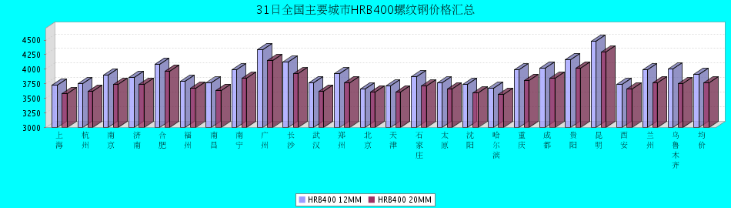
HRB400螺纹钢12MM价格走势图
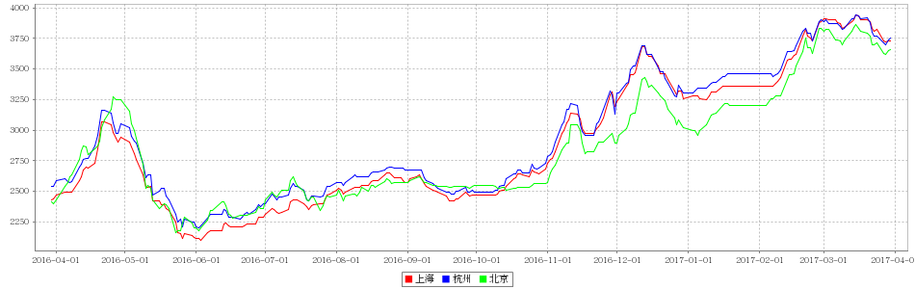
HRB400螺纹钢20MM价格走势图
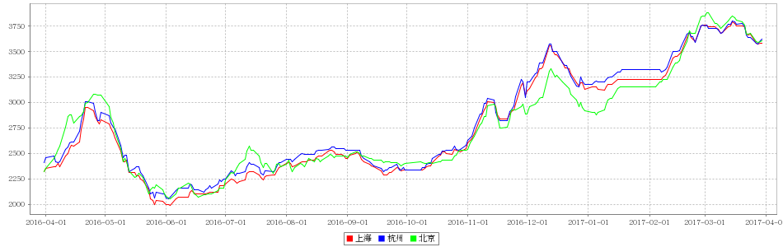

31日全国主要城市盘螺价格汇总
查看历史数据2017-03-31 12:13 来源：我的钢铁 资讯监督 用手机看行情
分享到：新浪微博QQ空间腾讯微博微信打印更多0
盘螺 | 上海 | 杭州 | 南京 | 济南 | 合肥 | 福州 | 南昌 | 南宁 | 广州 | 长沙 | 武汉 | 郑州 | 北京 | 天津 | 石家庄 | 太原 | 沈阳 | 哈尔滨 | 重庆 | 成都 | 贵阳 | 昆明 | 西安 | 兰州 | 乌鲁木齐 | 全国均价
HRB400(E) 8mm | 3810 | 3850 | 3950 | 3760 | 4150 | 3970 | 3860 | 4020 | 4340 | 3900 | 3860 | 3910 | 3650 | 3620 | 3920 | 3810 | 3690 | 3770 | 3950 | 4000 | 4160 | 4480 | 3810 | 4020 | 3860 | 3925
涨跌 | 0 | 0 | 0 | 0 | 0 | 0 | 0 | +10 | 0 | 0 | 0 | 0 | 0 | 0 | 0 | +20 | 0 | 0 | 0 | 0 | 0 | 0 | 0 | 0 | 0 | +1
产地 | 中天 | 中天 | 永钢 | 莱钢永锋 | 马钢 | 三钢 | 南（昌）钢 | 柳钢 | 韶钢 | 湘钢 | 鄂钢 | 济源 | 河钢承钢 | 河钢唐钢 | 邯钢 | 首钢长治 | 新抚钢 | 西林 | 水钢 | 威钢 | 水钢 | 昆钢 | 龙钢 | 酒钢 | 八钢 | -
 | 现货 | 现货 | 现货 | 现货 | 现货 | 现货 | 现货 | 现货 | 现货 | 现货 | 现货 | 现货 | 现货 | 现货 | 现货 | 现货 | 现货 | 现货 | 现货 | 现货 | 现货 | 现货 | 现货 | 现货 | 现货
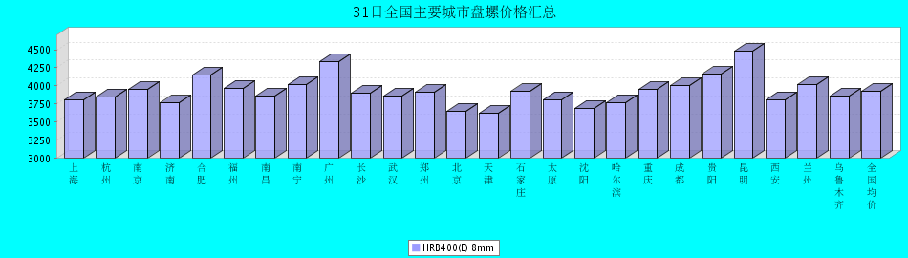

31日全国主要城市中厚板价格汇总
查看历史数据2017-03-31 11:59 来源：我的钢铁 资讯监督 用手机看行情
分享到：新浪微博QQ空间腾讯微博微信打印更多0
中板 | 上海 | 杭州 | 南京 | 济南 | 合肥 | 福州 | 南昌 | 广州 | 长沙 | 武汉 | 郑州 | 北京 | 天津 | 石家庄 | 太原 | 沈阳 | 哈尔滨 | 重庆 | 成都 | 昆明 | 西安 | 兰州 | 乌鲁木齐 | 均价
普8mm | 3810 | 3760 | - | 3900 | 3930 | 4000 | 3770 | 4160 | 3840 | 3910 | 3980 | - | 3750 | 3800 | 3820 | 3770 | 4040 | 4190 | 4140 | 3900 | 3950 | 4180 | 4240 | 3945
涨跌 | 0 | 0 | - | 0 | 0 | 0 | +20 | -10 | 0 | 0 | -10 | - | -30 | -10 | 0 | 0 | 0 | 0 | -20 | 0 | 0 | 0 | -10 | +4
产地 | 萍钢 | 萍钢 | 萍钢 | 济钢 | 马钢 | 三钢 | 新余 | 韶钢 | 新余 | 邯钢 | 邯钢 | - | 天钢 | 邯钢 | 太钢 | 鞍钢 | 鞍钢 | 重钢 | 酒钢 | 柳钢 | 酒钢 | 酒钢 | 八钢 | -
 | 现货 | 现货 | 现货 | 现货 | 现货 | 现货 | 现货 | 现货 | 现货 | 现货 | 现货 | 现货 | 现货 | 现货 | 现货 | 现货 | 现货 | 现货 | 现货 | 现货 | 现货 | 现货 | 现货
普20mm | 3600 | 3580 | 3610 | 3630 | 3650 | 3750 | 3600 | 3750 | 3630 | 3540 | 3610 | 3550 | 3450 | 3480 | 3560 | 3510 | 3710 | 3700 | 3830 | 3890 | 3640 | 3730 | 3970 | 3651
涨跌 | 0 | 0 | 0 | 0 | 0 | 0 | +20 | -10 | 0 | 0 | -10 | +20 | -30 | -10 | 0 | 0 | 0 | 0 | -20 | 0 | 0 | 0 | -10 | -2
产地 | 萍钢 | 萍钢 | 萍钢 | 济钢 | 马钢 | 三钢 | 新余 | 韶钢 | 湘钢 | 鄂钢 | 安阳 | 敬业 | 天钢 | 敬业 | 文丰 | 鞍钢 | 鞍钢 | 重钢 | 酒钢 | 柳钢 | 酒钢 | 酒钢 | 八钢 | -
 | 现货 | 现货 | 现货 | 现货 | 现货 | 现货 | 现货 | 现货 | 现货 | 现货 | 现货 | 现货 | 现货 | 现货 | 现货 | 现货 | 现货 | 现货 | 现货 | 现货 | 现货 | 现货 | 现货
低合金20mm | 3730 | 3710 | 3720 | 3760 | 3800 | 3900 | 3700 | 3900 | 3780 | 3680 | 3720 | 3710 | 3600 | 3610 | 3700 | 3710 | 3930 | 3850 | 3980 | 4030 | 3780 | 3840 | 4090 | 3793
涨跌 | 0 | 0 | 0 | 0 | 0 | 0 | +20 | -10 | 0 | 0 | -10 | +20 | -30 | 0 | 0 | 0 | 0 | 0 | -20 | 0 | 0 | 0 | -10 | -1
产地 | 萍钢 | 萍钢 | 萍钢 | 济钢 | 马钢 | 三钢 | 新余 | 韶钢 | 湘钢 | 鄂钢 | 安阳 | 敬业 | 天钢 | 敬业 | 文丰 | 鞍钢 | 鞍钢 | 重钢 | 酒钢 | 韶钢 | 酒钢 | 酒钢 | 八钢 | -
 | 现货 | 现货 | 现货 | 现货 | 现货 | 现货 | 现货 | 现货 | 现货 | 现货 | 现货 | 现货 | 现货 | 现货 | 现货 | 现货 | 现货 | 现货 | 现货 | 现货 | 现货 | 现货 | 现货
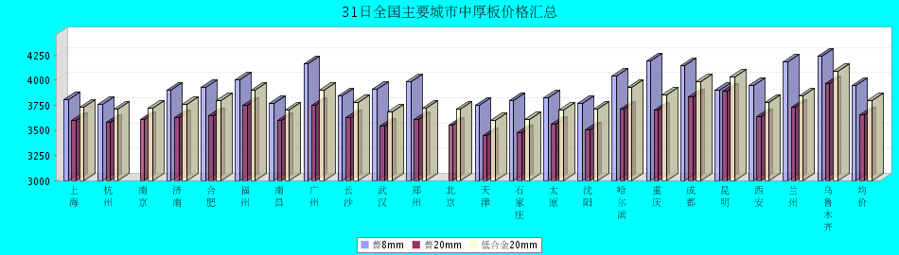
普8mm价格走势图
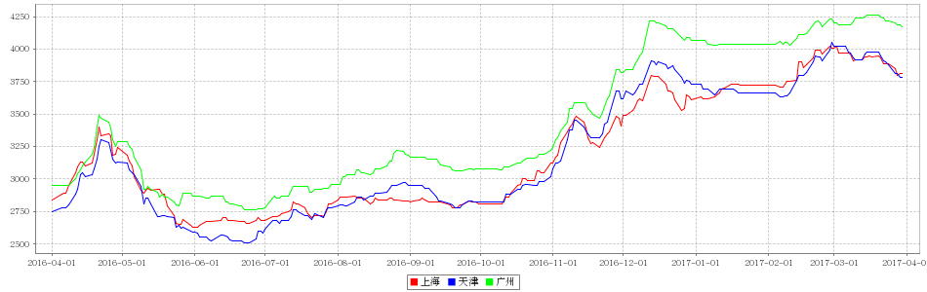
普20mm价格走势图
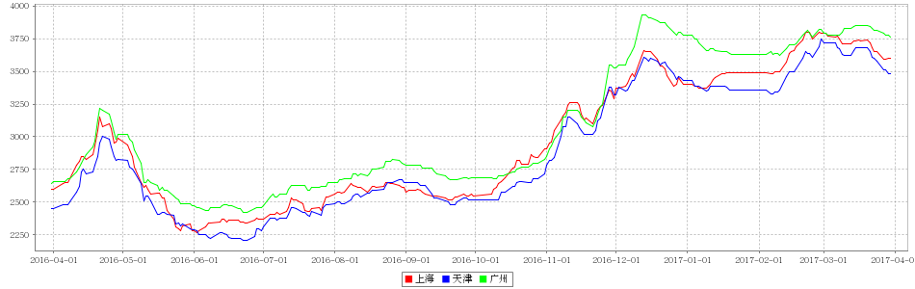
低合金20mm价格走势图
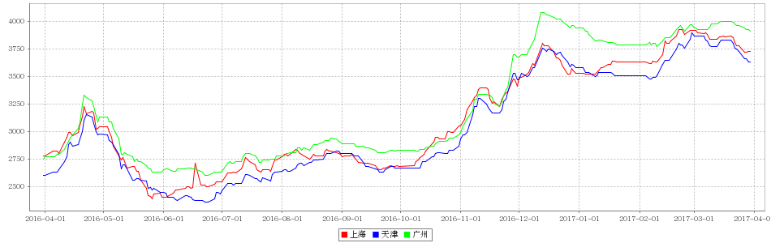

31日全国主要城市焊管价格汇总
查看历史数据2017-03-31 11:27 来源：我的钢铁 资讯监督 用手机看行情
分享到：新浪微博QQ空间腾讯微博微信打印更多0
直缝焊管 | 上海 | 杭州 | 南京 | 济南 | 合肥 | 福州 | 南昌 | 北京 | 天津 | 唐山 | 邯郸 | 包头 | 太原 | 广州 | 南宁 | 长沙 | 武汉 | 郑州 | 沈阳 | 长春 | 哈尔滨 | 重庆 | 成都 | 昆明 | 西安 | 兰州 | 乌鲁木齐 | 平均价
1.5寸*3.25 | 3690 | 3700 | 3730 | 3590 | 3730 | 4040 | 3920 | 3620 | 3480 | 3460 | 3600 | 3590 | 3540 | 3880 | 4000 | 3930 | 3800 | 3610 | 3650 | 3610 | 3500 | 4080 | 4080 | 4170 | 3800 | 4040 | 4250 | 3781
涨幅 | 0 | -50 | 0 | 0 | 0 | +30 | 0 | 0 | +20 | +20 | 0 | 0 | 0 | 0 | 0 | 0 | -20 | 0 | 0 | 0 | +20 | 0 | 0 | 0 | 0 | 0 | 0 | +1
产地 | 衡水华岐 | 衡水华岐 | 衡水华岐 | 友发/京华 | 天津友发 | 福建辉源 | 天津友发 | 京华 | 友发 | 友发 | 正大/友发 | 友发 | 友发 | 佛山振鸿 | 南宁蓝天 | 邯郸友发 | 正大 | 邯郸友发 | 雷明 | 吉林华歧 | 吉林华岐 | 成都华岐 | 成都华岐 | 通海方圆 | 友发 | 友发 | 八钢 | -
 | 现货 | 现货 | 现货 | 现货 | 现货 | 现货 | 现货 | 现货 | 现货 | 现货 | 现货 | 现货 | 现货 | 现货 | 现货 | 现货 | 现货 | 现货 | 现货 | 现货 | 现货 | 现货 | 现货 | 现货 | 现货 | 现货 | 现货
4寸*3.75 | 3750 | 3670 | 3680 | 3580 | 3700 | 4040 | 3850 | 3550 | 3460 | 3440 | 3550 | 3530 | 3530 | 3880 | 4050 | 3900 | 3780 | 3600 | 3650 | 3610 | 3500 | 4070 | 4070 | 4150 | 3720 | 3940 | 4150 | 3756
涨幅 | 0 | -50 | 0 | 0 | 0 | +30 | 0 | 0 | +20 | +20 | 0 | 0 | 0 | 0 | 0 | 0 | -20 | 0 | 0 | 0 | +20 | 0 | 0 | 0 | 0 | 0 | 0 | +1
产地 | 天津君诚 | 衡水华岐 | 衡水华岐 | 友发/京华 | 天津友发 | 福建辉源 | 天津友发 | 增洲 | 友发 | 增洲 | 正大/友发 | 友发 | 友发 | 佛山振鸿 | 佛山振鸿 | 邯郸友发 | 正大 | 邯郸友发 | 雷明 | 吉林华歧 | 吉林华岐 | 成都华岐 | 成都华岐 | 通海方圆 | 友发 | 友发 | 八钢 | -
 | 现货 | 现货 | 现货 | 现货 | 现货 | 现货 | 现货 | 现货 | 现货 | 现货 | 现货 | 现货 | 现货 | 现货 | 现货 | 现货 | 现货 | 现货 | 现货 | 现货 | 现货 | 现货 | 现货 | 现货 | 现货 | 现货 | 现货
备注 | 过磅 | 过磅 | 过磅 | 过磅 | 过磅 | 过磅 | 过磅 | 过磅 | 过磅 | 过磅 | 过磅 | 过磅 | 过磅 | 过磅 | 过磅 | 过磅 | 过磅 | 过磅 | 过磅 | 过磅 | 过磅 | 过磅 | 过磅 | 过磅 | 过磅 | 过磅 | 过磅 | -
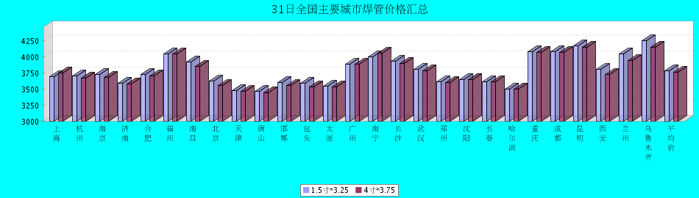

31日全国主要城市H型钢价格汇总
查看历史数据2017-03-31 11:29 来源：我的钢铁 资讯监督 用手机看行情
分享到：新浪微博QQ空间腾讯微博微信打印更多0
H型钢 | 上海 | 北京 | 天津 | 杭州 | 无锡 | 唐山 | 济南 | 太原 | 福州 | 成都 | 郑州 | 西安 | 鞍山 | 广州 | 均价
200*100 | 3320 | 3220 | 3230 | 3490 | 3340 | 3230 | 3320 | 3550 | 3500 | 3710 | - | 3880 | 3410 | 3540 | 3442
涨跌 | 0 | +10 | +10 | 0 | 0 | +10 | +50 | +100 | -50 | 0 | - | 0 | 0 | 0 | +10
产地 | 马钢 | 莱\日 | 莱\日 | 马钢 | 莱钢 | 莱\日 | 津西 | 莱钢 | 日照 | 莱钢 | - | 莱钢 | 津西 | 津西 | -
 | 现货 | 现货 | 现货 | 现货 | 现货 | 现货 | 现货 | 现货 | 现货 | 现货 | 现货 | 现货 | 现货 | 现货
300*300 | 3380 | 3270 | 3270 | 3570 | 3370 | 3290 | 3420 | 3640 | 3700 | 3800 | 3560 | 3860 | 3510 | 3740 | 3527
涨跌 | -20 | +10 | +10 | 0 | 0 | +10 | +20 | +40 | -50 | 0 | 0 | 0 | 0 | 0 | +1
产地 | 马钢 | 马\莱 | 马\莱 | 马钢 | 马钢 | 津西 | 津西 | 莱钢 | 日照 | 马钢 | 莱钢 | 莱钢 | 津西 | 马钢 | -
 | 现货 | 现货 | 现货 | 现货 | 现货 | 现货 | 现货 | 现货 | 现货 | 现货 | 现货 | 现货 | 现货 | 现货
400*200 | 3380 | 3310 | 3310 | 3490 | 3450 | 3300 | 3400 | 3600 | 3550 | 3770 | 3550 | 3720 | 3470 | 3650 | 3496
涨跌 | 0 | +10 | +10 | 0 | 0 | +10 | +20 | +40 | -50 | 0 | 0 | 0 | 0 | 0 | +2
产地 | 马钢 | 莱\津 | 莱\津 | 莱钢 | 莱钢 | 津西 | 津西 | 长治 | 日照 | 莱钢 | 莱钢 | 首钢长治 | 津西 | 马钢 | -
 | 现货 | 现货 | 现货 | 现货 | 现货 | 现货 | 现货 | 现货 | 现货 | 现货 | 现货 | 现货 | 现货 | 现货
588*300 | 3430 | 3320 | 3310 | 3660 | 3440 | 3270 | 3410 | 3610 | 3700 | 3710 | 3550 | 3990 | 3510 | 3720 | 3545
涨跌 | 0 | +10 | +10 | 0 | 0 | +10 | +20 | +40 | -50 | 0 | 0 | 0 | 0 | 0 | +3
产地 | 马钢 | 莱\津 | 莱\津 | 马钢 | 莱钢 | 津西 | 津西 | 莱钢 | 日照 | 马钢 | 莱钢 | 莱钢 | 津西 | 津西 | -
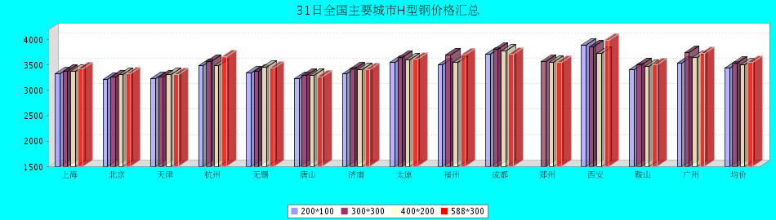

31日全国主要城市工角槽钢价格汇总
查看历史数据2017-03-31 11:50 来源：我的钢铁 资讯监督 用手机看行情
分享到：新浪微博QQ空间腾讯微博微信打印更多0
型材 | 上海 | 杭州 | 南京 | 济南 | 合肥 | 福州 | 南昌 | 广州 | 长沙 | 武汉 | 郑州 | 北京 | 天津 | 石家庄 | 太原 | 沈阳 | 哈尔滨 | 重庆 | 成都 | 昆明 | 西安 | 兰州 | 乌鲁木齐 | 均价
50*5角钢 | 3770 | 3840 | 3840 | 3600 | 3810 | 3770 | 3760 | 3800 | 4040 | 3830 | 3870 | 3220 | 3210 | 3340 | 3600 | 3660 | 3770 | 4020 | 4050 | 4380 | 3680 | 3760 | 3910 | 3762
涨跌 | 0 | 0 | 0 | 0 | 0 | -80 | 0 | 0 | 0 | 0 | 0 | -10 | 0 | 0 | 0 | 0 | 0 | 0 | 0 | 0 | +10 | +10 | 0 | -3
主导钢厂 | 马钢 | 马钢 | 马钢 | 安钢 | 马钢 | 唐山正丰 | 南钢 | 冀丰 | 安钢 | 安钢 | 安钢 | 首钢 | 兆博 | 唐山 | 唐山正丰 | 唐山正丰 | 唐山正丰 | 安阳 | 安阳 | 安钢 | 安钢 | 安钢 | 八钢 | -
 | 现货 | 现货 | 现货 | 现货 | 现货 | 现货 | 现货 | 现货 | 现货 | 现货 | 现货 | 现货 | 现货 | 现货 | 现货 | 现货 | 现货 | 现货 | 现货 | 现货 | 现货 | 现货 | 现货
16＃槽钢 | 3670 | 3760 | 3750 | 3620 | 3740 | 3770 | 3730 | 3810 | 3970 | 3840 | 3810 | 3320 | 3250 | 3300 | 3530 | 3490 | 3640 | 3690 | 3600 | 4250 | 3750 | 3980 | 3920 | 3704
涨跌 | 0 | 0 | 0 | 0 | 0 | -80 | 0 | 0 | 0 | 0 | 0 | -10 | 0 | 0 | -50 | 0 | 0 | -20 | 0 | 0 | +10 | +10 | 0 | -6
主导钢厂 | 马钢 | 马钢 | 马钢 | 济钢 | 马钢 | 唐山鑫诚 | 马钢 | 柳钢 | 东山冶金 | 马钢 | 济钢 | 中德 | 江天 | 唐山 | 唐山瑞隆 | 鞍山宝得 | 鞍山宝得 | 东山 | 东山 | 河北东山 | 河北东山 | 鞍山宝得 | 八钢 | -
 | 现货 | 现货 | 现货 | 现货 | 现货 | 现货 | 现货 | 现货 | 现货 | 现货 | 现货 | 现货 | 现货 | 现货 | 现货 | 现货 | 现货 | 现货 | 现货 | 现货 | 现货 | 现货 | 现货
25＃工字钢 | 3640 | 3900 | 3750 | 3700 | 3840 | 3820 | 3900 | 4200 | 4060 | 3970 | 3700 | 3220 | 3240 | 3300 | 3590 | 3340 | 3490 | 3820 | 3800 | 4200 | 4000 | 4010 | 4270 | 3772
涨跌 | 0 | 0 | 0 | 0 | 0 | -80 | 0 | 0 | 0 | 0 | 0 | -10 | 0 | 0 | +10 | 0 | 0 | -10 | 0 | -30 | +10 | +10 | 0 | -5
主导钢厂 | 莱钢 | 莱钢 | 莱钢 | 莱钢 | 武钢 | 日照 | 莱钢 | 日照 | 莱钢 | 包钢 | 莱钢 | 津西 | 唐山 | 唐山 | 唐山弘泰 | 东四 | 宝得 | 日照 | 日照 | 日照 | 日照 | 莱钢 | 海城 | -
 | 现货 | 现货 | 现货 | 现货 | 现货 | 现货 | 现货 | 现货 | 现货 | 现货 | 现货 | 现货 | 现货 | 现货 | 现货 | 现货 | 现货 | 现货 | 现货 | 现货 | 现货 | 现货 | 现货
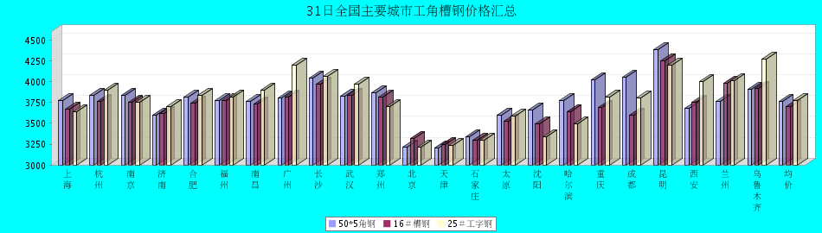

31日全国主要城市镀锌管价格汇总
查看历史数据2017-03-31 11:50 来源：我的钢铁 资讯监督 用手机看行情
分享到：新浪微博QQ空间腾讯微博微信打印更多1
镀锌焊管 | 上海 | 杭州 | 南京 | 济南 | 合肥 | 福州 | 南昌 | 北京 | 天津 | 唐山 | 邯郸 | 包头 | 太原 | 广州 | 南宁 | 长沙 | 武汉 | 郑州 | 沈阳 | 长春 | 哈尔滨 | 重庆 | 成都 | 昆明 | 西安 | 兰州 | 乌鲁木齐 | 平均价
1.5寸*3.25 | 4590 | 4490 | 4480 | 4560 | 4390 | 4560 | 4580 | 4550 | 4360 | 4290 | 4550 | 4230 | 4440 | 5090 | 4700 | 4750 | 4580 | 4390 | 4320 | 4230 | 4170 | 4770 | 4800 | 4800 | 4550 | 4570 | 4700 | 4537
涨幅 | 0 | -50 | 0 | 0 | 0 | +50 | -50 | 0 | 0 | 0 | 0 | 0 | 0 | 0 | 0 | 0 | -50 | 0 | 0 | +20 | 0 | 0 | 0 | 0 | 0 | 0 | 0 | -3
产地 | 天津君诚 | 衡水华岐 | 衡水华岐 | 友发 | 天津友发 | 君诚 | 邯郸友发 | 利达 | 友发 | 正金元 | 邯郸友发 | 友发 | 友发 | 友发 | 天津君诚 | 邯郸友发 | 邯郸友发 | 邯郸正大 | 正金元 | 吉林华岐 | 吉林华岐 | 成都华岐 | 华歧 | 邯郸友发 | 利达 | 君诚 | 友发 | -
4寸*3.75 | 4300 | 4180 | 4220 | 4270 | 4100 | 4270 | 4310 | 4300 | 4050 | 3980 | 4260 | 3940 | 4150 | 4790 | 4460 | 4420 | 4290 | 4080 | 3980 | 3980 | 3920 | 4450 | 4500 | 4500 | 4350 | 4320 | 4650 | 4260
涨幅 | 0 | -50 | 0 | 0 | 0 | +50 | -50 | 0 | 0 | 0 | 0 | 0 | 0 | 0 | 0 | 0 | -50 | 0 | 0 | +20 | 0 | 0 | 0 | 0 | 0 | 0 | 0 | -3
产地 | 天津友发 | 天津友发 | 天津友发 | 友发 | 天津友发 | 君诚 | 邯郸友发 | 利达 | 友发 | 正金元 | 邯郸友发 | 友发 | 友发 | 友发 | 天津君诚 | 衡水华岐 | 邯郸友发 | 邯郸正大 | 正金元 | 正金元 | 吉林华岐 | 成都华岐 | 华歧 | 邯郸友发 | 利达 | 君诚 | 友发 | -
备注 | 过磅 | 过磅 | 过磅 | 过磅 | 过磅 | 过磅 | 过磅 | 过磅 | 过磅 | 过磅 | 过磅 | 过磅 | 过磅 | 过磅 | 过磅 | 过磅 | 过磅 | 过磅 | 过磅 | 过磅 | 过磅 | 过磅 | 过磅 | 过磅 | 理计 | 过磅 | 过磅 | -
