14日全国主要城市线材价格汇总
查看历史数据2017-04-14 11:34 来源：我的钢铁 资讯监督 用手机看行情
分享到：新浪微博QQ空间腾讯微博微信打印更多0
线材 | 上海 | 杭州 | 南京 | 济南 | 合肥 | 福州 | 南昌 | 广州 | 长沙 | 武汉 | 郑州 | 北京 | 天津 | 石家庄 | 太原 | 沈阳 | 哈尔滨 | 重庆 | 成都 | 贵阳 | 昆明 | 西安 | 兰州 | 乌鲁木齐 | 均价
6.5高线HPB300 | - | 3650 | 3570 | - | 3740 | 3670 | 3530 | - | 3570 | 3590 | 3540 | 3700 | 3290 | - | 3560 | 3430 | 3540 | 3820 | 3770 | 3800 | 4320 | 3580 | 3800 | 3640 | 3656
涨跌 | - | +20 | 0 | - | 0 | +20 | 0 | - | -10 | +20 | 0 | 0 | 0 | - | 0 | 0 | 0 | 0 | 0 | +10 | 0 | 0 | -50 | 0 | -9
产地 | - | 中天 | 萍钢 | 莱钢永锋 | 马钢 | 三钢 | 南（昌）钢 | 韶钢 | 萍钢 | 鄂钢 | 信钢 | 河钢承钢 | 国义 | 邯钢 | 首钢长治 | 北台 | 西钢 | 达钢 | 达钢 | 水钢 | 昆钢 | 龙钢 | 酒钢 | 八钢 | -
 | 现货 | 现货 | 现货 | 现货 | 现货 | 现货 | 现货 | 现货 | 现货 | 现货 | 现货 | 现货 | 现货 | 现货 | 现货 | 现货 | 现货 | 现货 | 现货 | 现货 | 现货 | 现货 | 现货 | 现货
8.0高线HPB300 | 3570 | 3650 | 3570 | 3550 | 3740 | 3690 | 3530 | - | 3570 | 3590 | 3540 | 3660 | 3200 | - | 3560 | 3380 | 3490 | 3770 | 3720 | 3800 | 4320 | 3530 | 3770 | 3640 | 3629
涨跌 | 0 | +20 | 0 | +20 | 0 | +70 | 0 | - | -10 | +20 | 0 | 0 | 0 | - | 0 | 0 | 0 | 0 | 0 | +10 | 0 | 0 | -30 | 0 | -5
产地 | 中天 | 中天 | 萍钢 | 莱钢永锋 | 马钢 | 三钢 | 南（昌）钢 | 韶钢 | 萍钢 | 鄂钢 | 信钢 | 河钢承钢 | 安丰 | 邯钢 | 首钢长治 | 北台 | 西钢 | 达钢 | 达钢 | 水钢 | 昆钢 | 龙钢 | 酒钢 | 八钢 | -
 | 现货 | 现货 | 现货 | 现货 | 现货 | 现货 | 现货 | 现货 | 现货 | 现货 | 现货 | 现货 | 现货 | 现货 | 现货 | 现货 | 现货 | 现货 | 现货 | 现货 | 现货 | 现货 | 现货 | 现货
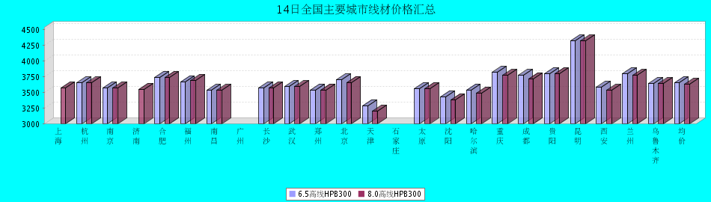
8.0高线HPB300价格走势图
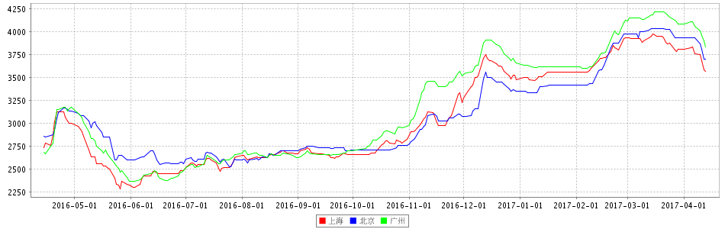
8.0高线HPB235价格走势图
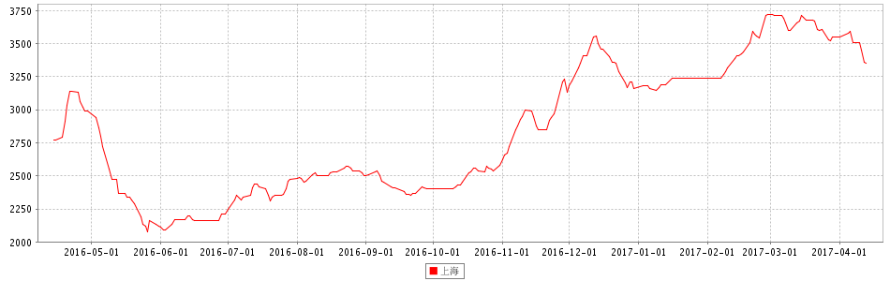

14日全国主要城市HRB400螺纹钢价格汇总
查看历史数据2017-04-14 11:38 来源：我的钢铁 资讯监督 用手机看行情
分享到：新浪微博QQ空间腾讯微博微信打印更多0
螺纹钢 | 上海 | 杭州 | 南京 | 济南 | 合肥 | 福州 | 南昌 | 南宁 | 广州 | 长沙 | 武汉 | 郑州 | 北京 | 天津 | 石家庄 | 太原 | 沈阳 | 哈尔滨 | 重庆 | 成都 | 贵阳 | 昆明 | 西安 | 兰州 | 乌鲁木齐 | 均价
HRB400 12MM | 3500 | 3560 | 3630 | 3620 | 3840 | 3610 | 3530 | 3820 | - | 3820 | 3520 | 3630 | 3360 | 3380 | 3620 | 3560 | 3550 | 3510 | 3900 | 3880 | 3990 | 4430 | 3470 | 3670 | 3910 | 3680
涨幅 | +10 | +20 | +10 | +20 | 0 | +20 | 0 | 0 | - | 0 | +20 | 0 | 0 | +20 | 0 | 0 | 0 | 0 | 0 | 0 | +10 | 0 | 0 | -20 | 0 | -14
产地 | 申特 | 中天 | 永钢 | 莱钢 | 马钢 | 三钢 | 南(昌)钢 | 柳钢 | 韶钢 | 涟钢 | 新兴铸管 | 安钢 | 河钢承钢 | 河钢承钢 | 邯钢 | 首钢长治 | 新抚钢 | 西钢 | 达钢 | 威钢 | 水钢 | 昆钢 | 龙钢 | 酒钢 | 八钢 | -
计重方式 | 理计 | 理计 | 理计 | 理计 | 理计 | 理计 | 理计 | 理计 | 过磅 | 过磅 | 理计 | 理计 | 理计 | 理计 | 理计 | 理计 | 理计 | 理计 | 过磅 | 过磅 | 过磅 | 理计 | 理计 | 理计 | 理计 | -
30天均价 | 3750 | 3766 | 3898 | 3878 | 4102 | 3776 | 3752 | 4050 | - | 4120 | 3773 | 3956 | 3640 | 3690 | 3847 | 3798 | 3744 | 3695 | 4016 | 4043 | 4207 | 4513 | 3767 | 3955 | 4000 | 3906
 | 现货 | 现货 | 现货 | 现货 | 现货 | 现货 | 现货 | 现货 | 现货 | 现货 | 现货 | 现货 | 现货 | 现货 | 现货 | 现货 | 现货 | 现货 | 现货 | 现货 | 现货 | 现货 | 现货 | 现货 | 现货
HRB400 20MM | 3350 | 3430 | 3470 | 3540 | 3720 | 3490 | 3410 | 3670 | - | 3620 | 3370 | 3480 | 3260 | 3250 | 3370 | 3460 | 3400 | 3410 | 3700 | 3690 | 3840 | 4240 | 3390 | 3450 | 3660 | 3528
涨幅 | +10 | +20 | +10 | +60 | 0 | +20 | 0 | 0 | - | 0 | +20 | 0 | 0 | 0 | 0 | 0 | 0 | 0 | 0 | +10 | +10 | 0 | 0 | -40 | 0 | -13
产地 | 中天 | 中天 | 沙钢 | 莱钢 | 马钢 | 三钢 | 南(昌)钢 | 柳钢 | 韶钢 | 涟钢 | 萍钢 | 安钢 | 河钢承钢 | 河钢承钢 | 邯钢 | 首钢长治 | 新抚钢 | 西钢 | 达钢 | 威钢 | 水钢 | 昆钢 | 龙钢 | 酒钢 | 八钢 | -
计重方式 | 理计 | 理计 | 理计 | 理计 | 理计 | 理计 | 理计 | 理计 | 过磅 | 过磅 | 理计 | 理计 | 理计 | 理计 | 理计 | 理计 | 理计 | 理计 | 过磅 | 过磅 | 过磅 | 理计 | 理计 | 理计 | 理计 | -
30天均价 | 3600 | 3624 | 3740 | 3758 | 3973 | 3656 | 3633 | 3891 | - | 3920 | 3635 | 3793 | 3595 | 3601 | 3730 | 3698 | 3605 | 3590 | 3842 | 3860 | 4057 | 4320 | 3675 | 3761 | 3750 | 3763
 | 现货 | 现货 | 现货 | 现货 | 现货 | 现货 | 现货 | 现货 | 现货 | 现货 | 现货 | 现货 | 现货 | 现货 | 现货 | 现货 | 现货 | 现货 | 现货 | 现货 | 现货 | 现货 | 现货 | 现货 | 现货
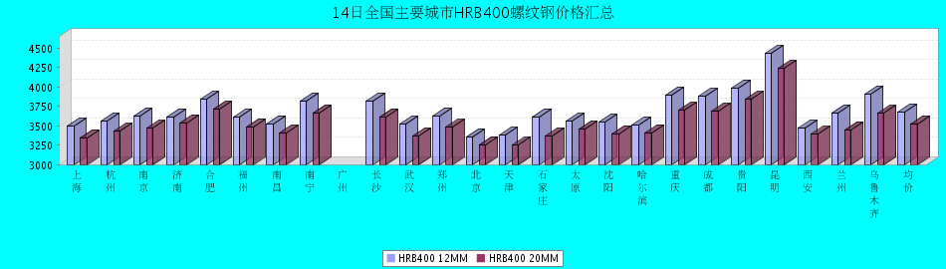
HRB400螺纹钢12MM价格走势图
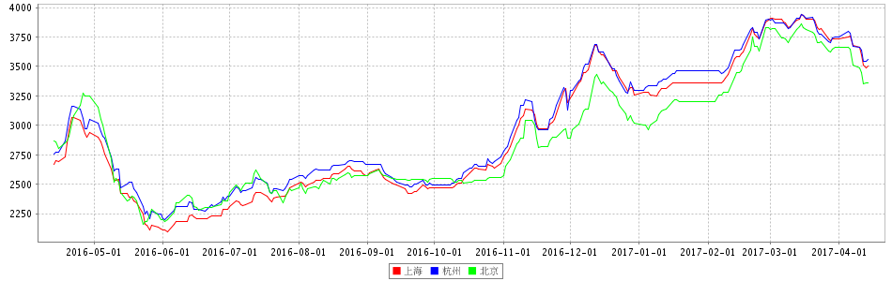
HRB400螺纹钢20MM价格走势图
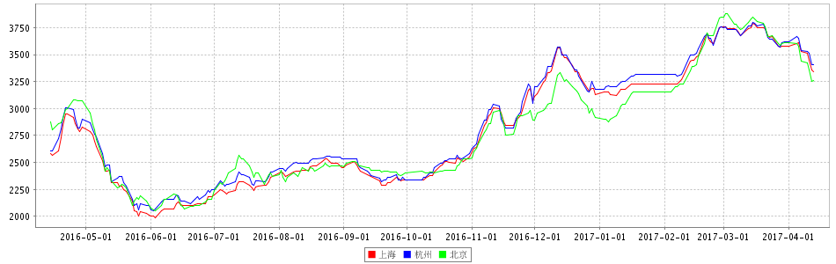

14日全国主要城市盘螺价格汇总
查看历史数据2017-04-14 11:42 来源：我的钢铁 资讯监督 用手机看行情
分享到：新浪微博QQ空间腾讯微博微信打印更多0
盘螺 | 上海 | 杭州 | 南京 | 济南 | 合肥 | 福州 | 南昌 | 南宁 | 广州 | 长沙 | 武汉 | 郑州 | 北京 | 天津 | 石家庄 | 太原 | 沈阳 | 哈尔滨 | 重庆 | 成都 | 贵阳 | 昆明 | 西安 | 兰州 | 乌鲁木齐 | 全国均价
HRB400(E) 8mm | 3550 | 3650 | 3690 | 3580 | 3800 | 3790 | 3620 | 3860 | - | 3670 | 3620 | 3650 | 3300 | 3290 | 3510 | 3630 | 3490 | 3600 | 3800 | 3880 | 3960 | 4430 | 3540 | 3720 | 3770 | 3683
涨跌 | 0 | +10 | 0 | +50 | -20 | +70 | 0 | 0 | - | -10 | +20 | 0 | +10 | 0 | 0 | 0 | 0 | 0 | 0 | 0 | +10 | 0 | 0 | -30 | 0 | -13
产地 | 中天 | 中天 | 永钢 | 莱钢永锋 | 马钢 | 三钢 | 南（昌）钢 | 柳钢 | 韶钢 | 湘钢 | 鄂钢 | 济源 | 河钢承钢 | 河钢唐钢 | 邯钢 | 首钢长治 | 新抚钢 | 西林 | 水钢 | 威钢 | 水钢 | 昆钢 | 龙钢 | 酒钢 | 八钢 | -
 | 现货 | 现货 | 现货 | 现货 | 现货 | 现货 | 现货 | 现货 | 现货 | 现货 | 现货 | 现货 | 现货 | 现货 | 现货 | 现货 | 现货 | 现货 | 现货 | 现货 | 现货 | 现货 | 现货 | 现货 | 现货
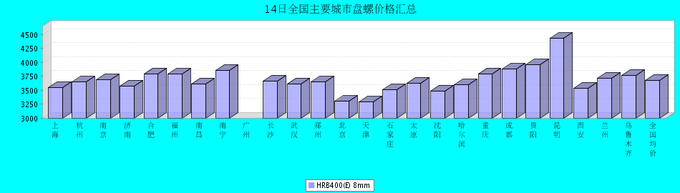

14日全国主要城市中厚板价格汇总
查看历史数据2017-04-14 11:16 来源：我的钢铁 资讯监督 用手机看行情
分享到：新浪微博QQ空间腾讯微博微信打印更多0
中板 | 上海 | 杭州 | 南京 | 济南 | 合肥 | 福州 | 南昌 | 广州 | 长沙 | 武汉 | 郑州 | 北京 | 天津 | 石家庄 | 太原 | 沈阳 | 哈尔滨 | 重庆 | 成都 | 昆明 | 西安 | 兰州 | 乌鲁木齐 | 均价
普8mm | 3660 | 3580 | - | 3690 | 3680 | 3750 | 3630 | 3890 | 3560 | 3730 | 3680 | - | 3470 | 3510 | 3510 | 3570 | 3790 | 4020 | 3910 | 3780 | 3730 | 3950 | 4140 | 3725
涨跌 | +10 | 0 | - | -30 | 0 | -50 | 0 | -30 | -20 | 0 | +20 | - | -20 | +10 | 0 | 0 | 0 | -10 | 0 | 0 | +20 | -50 | -30 | -9
产地 | 萍钢 | 萍钢 | 萍钢 | 济钢 | 马钢 | 三钢 | 新余 | 韶钢 | 新余 | 邯钢 | 邯钢 | - | 天钢 | 邯钢 | 太钢 | 鞍钢 | 鞍钢 | 重钢 | 酒钢 | 柳钢 | 酒钢 | 酒钢 | 八钢 | -
 | 现货 | 现货 | 现货 | 现货 | 现货 | 现货 | 现货 | 现货 | 现货 | 现货 | 现货 | 现货 | 现货 | 现货 | 现货 | 现货 | 现货 | 现货 | 现货 | 现货 | 现货 | 现货 | 现货
普20mm | 3390 | 3400 | 3390 | 3420 | 3400 | 3500 | 3460 | 3480 | 3350 | 3310 | 3310 | 3180 | 3170 | 3190 | 3250 | 3320 | 3460 | 3530 | 3600 | 3780 | 3420 | 3500 | 3870 | 3421
涨跌 | +10 | 0 | -10 | -30 | 0 | -50 | 0 | -30 | -20 | 0 | +20 | -30 | -20 | +10 | 0 | 0 | 0 | -10 | 0 | 0 | +20 | -50 | -30 | -9
产地 | 萍钢 | 萍钢 | 萍钢 | 济钢 | 马钢 | 三钢 | 新余 | 韶钢 | 湘钢 | 鄂钢 | 安阳 | 敬业 | 天钢 | 敬业 | 文丰 | 鞍钢 | 鞍钢 | 重钢 | 酒钢 | 柳钢 | 酒钢 | 酒钢 | 八钢 | -
 | 现货 | 现货 | 现货 | 现货 | 现货 | 现货 | 现货 | 现货 | 现货 | 现货 | 现货 | 现货 | 现货 | 现货 | 现货 | 现货 | 现货 | 现货 | 现货 | 现货 | 现货 | 现货 | 现货
低合金20mm | 3530 | 3530 | 3500 | 3550 | 3550 | 3650 | 3560 | 3630 | 3500 | 3430 | 3420 | 3340 | 3320 | 3350 | 3390 | 3510 | 3680 | 3680 | 3750 | 3920 | 3560 | 3610 | 3990 | 3563
涨跌 | +10 | 0 | -10 | -30 | 0 | -50 | 0 | -30 | -20 | 0 | +20 | -30 | -20 | +10 | 0 | 0 | 0 | -10 | 0 | 0 | +20 | -50 | -30 | -10
产地 | 萍钢 | 萍钢 | 萍钢 | 济钢 | 马钢 | 三钢 | 新余 | 韶钢 | 湘钢 | 鄂钢 | 安阳 | 敬业 | 天钢 | 敬业 | 文丰 | 鞍钢 | 鞍钢 | 重钢 | 酒钢 | 韶钢 | 酒钢 | 酒钢 | 八钢 | -
 | 现货 | 现货 | 现货 | 现货 | 现货 | 现货 | 现货 | 现货 | 现货 | 现货 | 现货 | 现货 | 现货 | 现货 | 现货 | 现货 | 现货 | 现货 | 现货 | 现货 | 现货 | 现货 | 现货
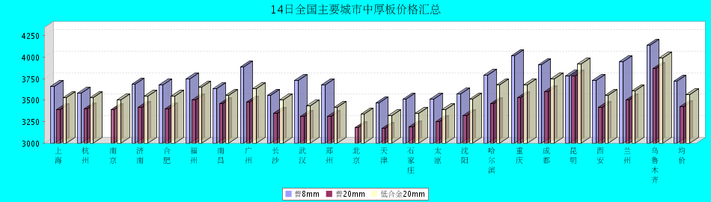
普8mm价格走势图
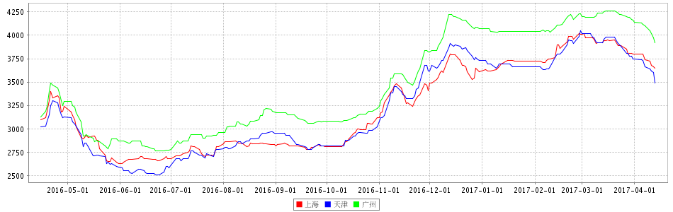
普20mm价格走势图
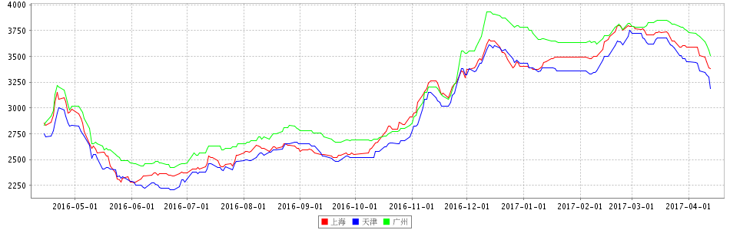
低合金20mm价格走势图
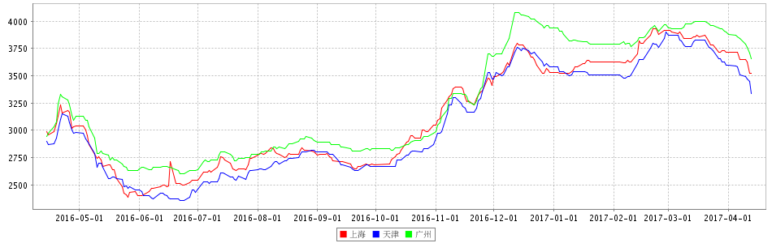

14日全国主要城市焊管价格汇总
查看历史数据2017-04-14 11:12 来源：我的钢铁 资讯监督 用手机看行情
分享到：新浪微博QQ空间腾讯微博微信打印更多0
直缝焊管 | 上海 | 杭州 | 南京 | 济南 | 合肥 | 福州 | 南昌 | 北京 | 天津 | 唐山 | 邯郸 | 包头 | 太原 | 广州 | 南宁 | 长沙 | 武汉 | 郑州 | 沈阳 | 长春 | 哈尔滨 | 重庆 | 成都 | 昆明 | 西安 | 兰州 | 乌鲁木齐 | 平均价
1.5寸*3.25 | 3510 | 3590 | 3580 | - | 3400 | 3820 | 3780 | 3480 | 3250 | 3220 | - | 3520 | 3410 | 3650 | 3750 | 3730 | 3620 | 3370 | 3240 | 3320 | 3340 | 3840 | 3950 | 3970 | 3800 | 3900 | 4100 | 3606
涨幅 | -50 | 0 | +30 | - | 0 | -30 | 0 | -20 | 0 | 0 | - | 0 | 0 | 0 | 0 | 0 | -30 | -90 | 0 | -60 | 0 | 0 | 0 | 0 | 0 | 0 | 0 | +3
产地 | 衡水华岐 | 衡水华岐 | 衡水华岐 | 友发/京华 | 天津友发 | 福建辉源 | 天津友发 | 京华 | 友发 | 友发 | 正大/友发 | 友发 | 友发 | 佛山振鸿 | 南宁蓝天 | 邯郸友发 | 正大 | 邯郸友发 | 雷明 | 吉林华歧 | 吉林华岐 | 成都华岐 | 成都华岐 | 通海方圆 | 友发 | 友发 | 八钢 | -
 | 现货 | 现货 | 现货 | 现货 | 现货 | 现货 | 现货 | 现货 | 现货 | 现货 | 现货 | 现货 | 现货 | 现货 | 现货 | 现货 | 现货 | 现货 | 现货 | 现货 | 现货 | 现货 | 现货 | 现货 | 现货 | 现货 | 现货
4寸*3.75 | 3570 | 3560 | 3530 | - | 3370 | 3820 | 3730 | 3410 | 3230 | 3200 | - | 3460 | 3400 | 3650 | 3800 | 3700 | 3600 | 3360 | 3240 | 3320 | 3340 | 3830 | 3940 | 3950 | 3720 | 3800 | 4000 | 3581
涨幅 | -50 | 0 | +30 | - | 0 | -30 | 0 | -20 | 0 | 0 | - | 0 | 0 | 0 | 0 | 0 | -30 | -90 | 0 | -60 | 0 | 0 | 0 | 0 | 0 | 0 | 0 | +3
产地 | 天津君诚 | 衡水华岐 | 衡水华岐 | 友发/京华 | 天津友发 | 福建辉源 | 天津友发 | 增洲 | 友发 | 增洲 | 正大/友发 | 友发 | 友发 | 佛山振鸿 | 佛山振鸿 | 邯郸友发 | 正大 | 邯郸友发 | 雷明 | 吉林华歧 | 吉林华岐 | 成都华岐 | 成都华岐 | 通海方圆 | 友发 | 友发 | 八钢 | -
 | 现货 | 现货 | 现货 | 现货 | 现货 | 现货 | 现货 | 现货 | 现货 | 现货 | 现货 | 现货 | 现货 | 现货 | 现货 | 现货 | 现货 | 现货 | 现货 | 现货 | 现货 | 现货 | 现货 | 现货 | 现货 | 现货 | 现货
备注 | 过磅 | 过磅 | 过磅 | 过磅 | 过磅 | 过磅 | 过磅 | 过磅 | 过磅 | 过磅 | 过磅 | 过磅 | 过磅 | 过磅 | 过磅 | 过磅 | 过磅 | 过磅 | 过磅 | 过磅 | 过磅 | 过磅 | 过磅 | 过磅 | 过磅 | 过磅 | 过磅 | -
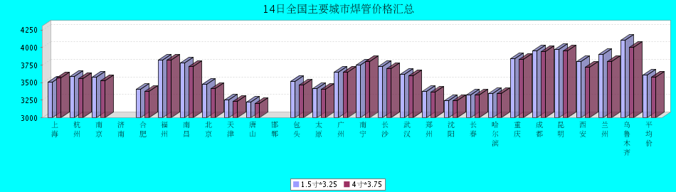

14日全国主要城市H型钢价格汇总
查看历史数据2017-04-14 11:20 来源：我的钢铁 资讯监督 用手机看行情
分享到：新浪微博QQ空间腾讯微博微信打印更多0
H型钢 | 上海 | 北京 | 天津 | 杭州 | 无锡 | 唐山 | 济南 | 太原 | 福州 | 成都 | 郑州 | 西安 | 鞍山 | 广州 | 均价
200*100 | 3060 | 3100 | 3090 | 3220 | 3090 | 3050 | 3130 | - | 3350 | 3560 | - | 3720 | 3220 | 3460 | 3254
涨跌 | -30 | -20 | 0 | -70 | -20 | -40 | 0 | - | 0 | 0 | - | 0 | 0 | 0 | -15
产地 | 马钢 | 莱\日 | 莱\日 | 马钢 | 莱钢 | 津西 | 津西 | 莱钢 | 日照 | 莱钢 | - | 莱钢 | 津西 | 津西 | -
 | 现货 | 现货 | 现货 | 现货 | 现货 | 现货 | 现货 | 现货 | 现货 | 现货 | 现货 | 现货 | 现货 | 现货
300*300 | 3100 | 3080 | 3120 | 3270 | 3120 | 3100 | 3230 | - | 3550 | 3650 | 3300 | 3700 | 3320 | 3660 | 3323
涨跌 | -50 | -20 | 0 | -80 | -20 | -20 | 0 | - | 0 | 0 | -60 | 0 | 0 | 0 | -19
产地 | 马钢 | 马\莱 | 马\莱 | 马钢 | 马钢 | 津西 | 津西 | 莱钢 | 日照 | 马钢 | 莱钢 | 莱钢 | 津西 | 马钢 | -
 | 现货 | 现货 | 现货 | 现货 | 现货 | 现货 | 现货 | 现货 | 现货 | 现货 | 现货 | 现货 | 现货 | 现货
400*200 | 3100 | 3100 | 3160 | 3220 | 3200 | 3100 | 3210 | 3270 | 3400 | 3620 | 3340 | 3560 | 3280 | 3570 | 3295
涨跌 | -50 | -20 | 0 | -50 | -20 | -20 | 0 | 0 | 0 | 0 | -60 | 0 | 0 | 0 | -16
产地 | 马钢 | 莱\津 | 莱\津 | 莱钢 | 莱钢 | 津西 | 津西 | 长治 | 日照 | 莱钢 | 莱钢 | 首钢长治 | 津西 | 马钢 | -
 | 现货 | 现货 | 现货 | 现货 | 现货 | 现货 | 现货 | 现货 | 现货 | 现货 | 现货 | 现货 | 现货 | 现货
588*300 | 3150 | 3090 | 3130 | 3340 | 3190 | 3110 | 3220 | - | 3550 | 3560 | 3360 | 3830 | 3320 | 3640 | 3345
涨跌 | -50 | -40 | 0 | -100 | -20 | -70 | 0 | - | 0 | 0 | -100 | 0 | 0 | 0 | -30
产地 | 马钢 | 莱\津 | 莱\津 | 马钢 | 莱钢 | 津西 | 津西 | 莱钢 | 日照 | 马钢 | 莱钢 | 莱钢 | 津西 | 津西 | -
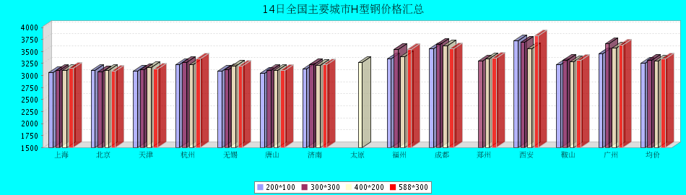

14日全国主要城市工角槽钢价格汇总
查看历史数据2017-04-14 11:32 来源：我的钢铁 资讯监督 用手机看行情
分享到：新浪微博QQ空间腾讯微博微信打印更多0
型材 | 上海 | 杭州 | 南京 | 济南 | 合肥 | 福州 | 南昌 | 广州 | 长沙 | 武汉 | 郑州 | 北京 | 天津 | 石家庄 | 太原 | 沈阳 | 哈尔滨 | 重庆 | 成都 | 昆明 | 西安 | 兰州 | 乌鲁木齐 | 均价
50*5角钢 | 3540 | 3720 | 3650 | 3380 | 3640 | 3550 | 3670 | 3640 | 3830 | 3720 | 3660 | 3000 | 3040 | 3150 | 3290 | 3340 | 3450 | 3910 | 3930 | 4170 | 3480 | 3560 | 3760 | 3569
涨跌 | -30 | -30 | -50 | 0 | 0 | 0 | 0 | 0 | 0 | 0 | -20 | 0 | 0 | 0 | 0 | 0 | 0 | -30 | 0 | 0 | 0 | 0 | 0 | -7
主导钢厂 | 马钢 | 马钢 | 马钢 | 安钢 | 马钢 | 唐山正丰 | 南钢 | 冀丰 | 安钢 | 安钢 | 安钢 | 首钢 | 兆博 | 唐山 | 唐山正丰 | 唐山正丰 | 唐山正丰 | 安阳 | 安阳 | 安钢 | 安钢 | 安钢 | 八钢 | -
 | 现货 | 现货 | 现货 | 现货 | 现货 | 现货 | 现货 | 现货 | 现货 | 现货 | 现货 | 现货 | 现货 | 现货 | 现货 | 现货 | 现货 | 现货 | 现货 | 现货 | 现货 | 现货 | 现货
16＃槽钢 | 3510 | 3620 | 3610 | 3360 | 3590 | 3550 | 3640 | 3650 | 3760 | 3720 | 3600 | 3100 | 3090 | 3140 | 3310 | 3240 | 3390 | 3490 | 3370 | 4090 | 3550 | 3780 | 3780 | 3519
涨跌 | -20 | -30 | -20 | 0 | 0 | 0 | 0 | 0 | 0 | 0 | -20 | 0 | 0 | 0 | +30 | 0 | 0 | -10 | 0 | 0 | 0 | 0 | 0 | -3
主导钢厂 | 马钢 | 马钢 | 马钢 | 济钢 | 马钢 | 唐山鑫诚 | 马钢 | 柳钢 | 东山冶金 | 马钢 | 济钢 | 中德 | 江天 | 唐山 | 唐山瑞隆 | 鞍山宝得 | 鞍山宝得 | 东山 | 东山 | 河北东山 | 河北东山 | 鞍山宝得 | 八钢 | -
 | 现货 | 现货 | 现货 | 现货 | 现货 | 现货 | 现货 | 现货 | 现货 | 现货 | 现货 | 现货 | 现货 | 现货 | 现货 | 现货 | 现货 | 现货 | 现货 | 现货 | 现货 | 现货 | 现货
25＃工字钢 | 3490 | 3660 | 3520 | 3460 | 3690 | 3650 | 3750 | 4060 | 3900 | 3820 | 3600 | 3020 | 3110 | 3170 | 3360 | 3150 | 3300 | 3670 | 3630 | 4020 | 3800 | 3810 | 4120 | 3598
涨跌 | -20 | -50 | -50 | 0 | 0 | 0 | 0 | 0 | 0 | 0 | -20 | 0 | 0 | 0 | +20 | 0 | 0 | 0 | 0 | -20 | 0 | 0 | 0 | -6
主导钢厂 | 莱钢 | 莱钢 | 莱钢 | 莱钢 | 武钢 | 日照 | 莱钢 | 日照 | 莱钢 | 包钢 | 莱钢 | 津西 | 唐山 | 唐山 | 唐山弘泰 | 东四 | 宝得 | 日照 | 日照 | 日照 | 日照 | 莱钢 | 海城 | -
 | 现货 | 现货 | 现货 | 现货 | 现货 | 现货 | 现货 | 现货 | 现货 | 现货 | 现货 | 现货 | 现货 | 现货 | 现货 | 现货 | 现货 | 现货 | 现货 | 现货 | 现货 | 现货 | 现货
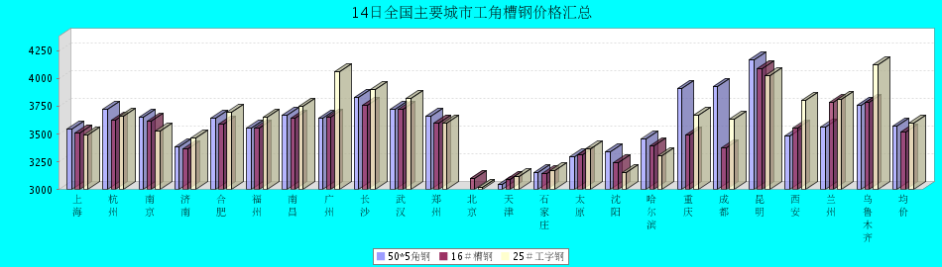

14日全国主要城市镀锌管价格汇总
查看历史数据2017-04-14 11:15 来源：我的钢铁 资讯监督 用手机看行情
分享到：新浪微博QQ空间腾讯微博微信打印更多0
镀锌焊管 | 上海 | 杭州 | 南京 | 济南 | 合肥 | 福州 | 南昌 | 北京 | 天津 | 唐山 | 邯郸 | 包头 | 太原 | 广州 | 南宁 | 长沙 | 武汉 | 郑州 | 沈阳 | 长春 | 哈尔滨 | 重庆 | 成都 | 昆明 | 西安 | 兰州 | 乌鲁木齐 | 平均价
1.5寸*3.25 | 4410 | 4390 | 4250 | - | 4230 | 4380 | 4380 | 4420 | 4050 | 3960 | 4300 | 4100 | 4310 | 4870 | 4570 | 4460 | 4370 | 4220 | 4120 | 4000 | 4000 | 4520 | 4660 | 4650 | 4450 | 4440 | 4650 | 4352
涨幅 | 0 | 0 | -50 | - | +30 | 0 | 0 | 0 | 0 | -60 | +30 | 0 | +30 | +30 | +50 | 0 | -60 | 0 | 0 | -40 | 0 | 0 | 0 | 0 | 0 | 0 | 0 | +1
产地 | 天津君诚 | 衡水华岐 | 衡水华岐 | 友发 | 天津友发 | 君诚 | 邯郸友发 | 利达 | 友发 | 正金元 | 邯郸友发 | 友发 | 友发 | 友发 | 天津君诚 | 邯郸友发 | 邯郸友发 | 邯郸正大 | 正金元 | 吉林华岐 | 吉林华岐 | 成都华岐 | 华歧 | 邯郸友发 | 利达 | 君诚 | 友发 | -
4寸*3.75 | 4150 | 4100 | 4010 | - | 3940 | 4090 | 4090 | 4170 | 3740 | 3650 | 4010 | 3810 | 4020 | 4570 | 4330 | 4200 | 4080 | 3910 | 3780 | 3750 | 3750 | 4220 | 4350 | 4350 | 4250 | 4190 | 4600 | 4081
涨幅 | 0 | 0 | +20 | - | +30 | 0 | 0 | 0 | 0 | -60 | +30 | 0 | +30 | +30 | +50 | 0 | -60 | 0 | 0 | -40 | 0 | 0 | 0 | 0 | 0 | 0 | 0 | +4
产地 | 天津友发 | 天津友发 | 天津友发 | 友发 | 天津友发 | 君诚 | 邯郸友发 | 利达 | 友发 | 正金元 | 邯郸友发 | 友发 | 友发 | 友发 | 天津君诚 | 衡水华岐 | 邯郸友发 | 邯郸正大 | 正金元 | 正金元 | 吉林华岐 | 成都华岐 | 华歧 | 邯郸友发 | 利达 | 君诚 | 友发 | -
备注 | 过磅 | 过磅 | 过磅 | 过磅 | 过磅 | 过磅 | 过磅 | 过磅 | 过磅 | 过磅 | 过磅 | 过磅 | 过磅 | 过磅 | 过磅 | 过磅 | 过磅 | 过磅 | 过磅 | 过磅 | 过磅 | 过磅 | 过磅 | 过磅 | 理计 | 过磅 | 过磅 | -
